Annexes
Annex I: | Antigua and Barbuda Declaration on School Safety in the Caribbean | 2
Annex II: | Caribbean Road Map for School Safety | 4
Annex III: | National achievements, challenges and priorities per country | 10
Annex IV: | Market place - description of presented resource | 15
Annex V: | Agenda | 19
Annex VI: | Participants list | 23
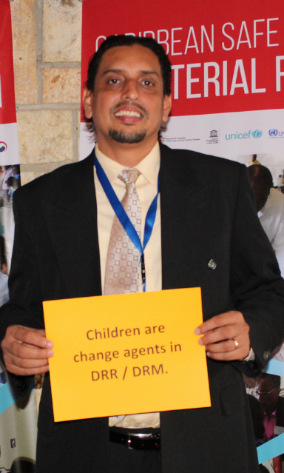
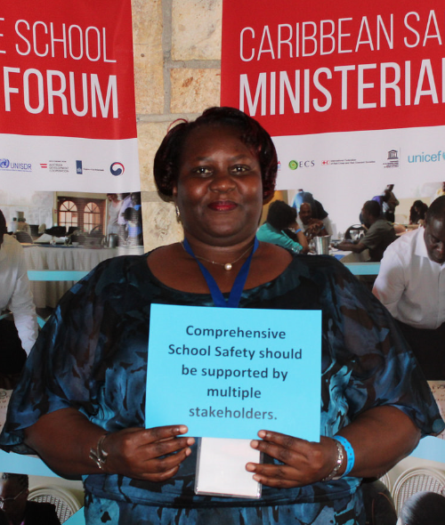
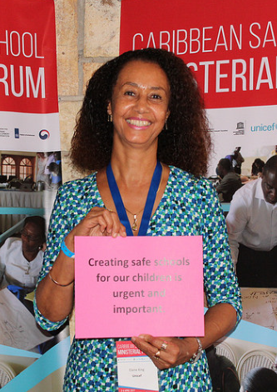
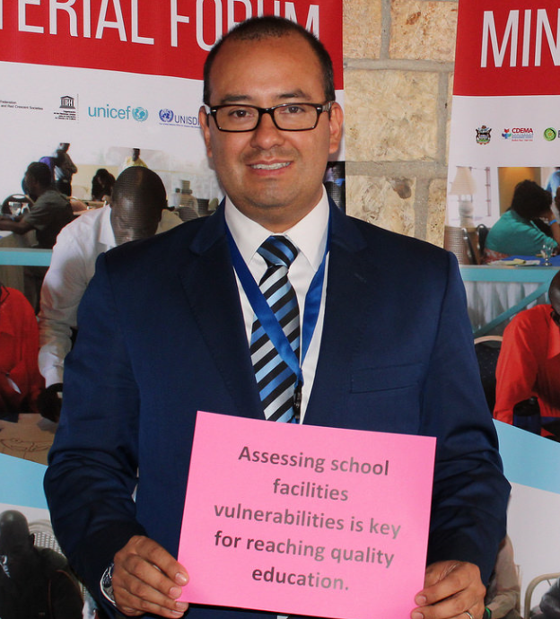
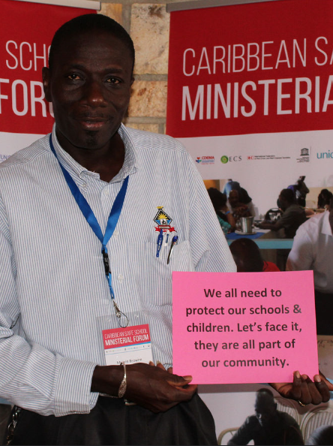
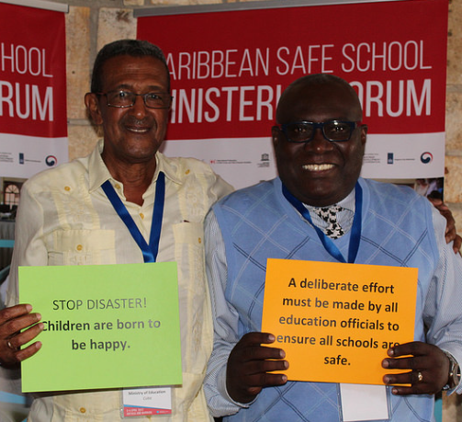
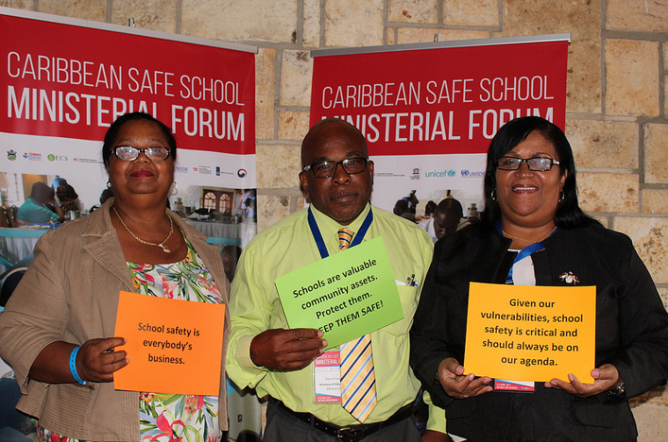
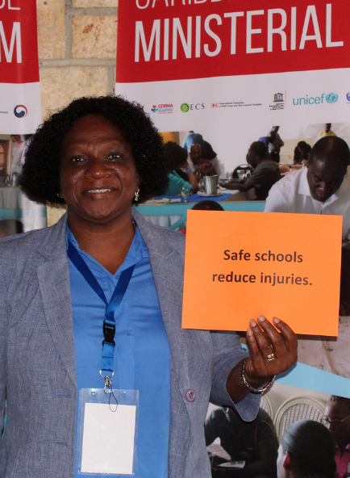
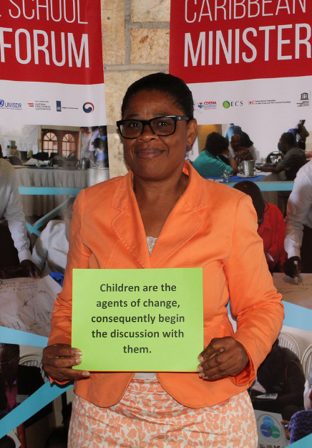
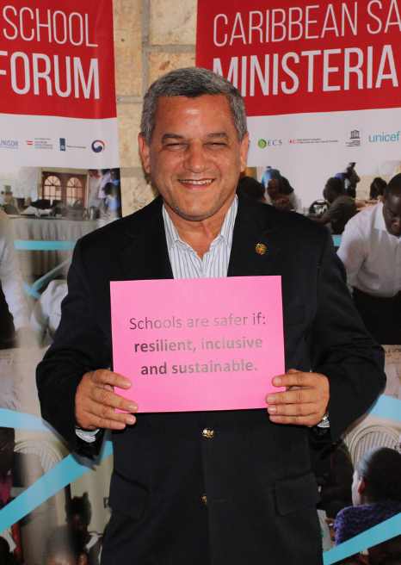
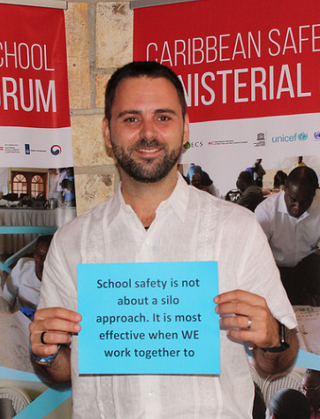
Annex I: Antigua and Barbuda Declaration on School Safety in the Caribbean
First meeting of Ministers of Education and High-level Authorities of the Education Sector on the Implementation of the Worldwide Initiative on School Safety and the Comprehensive Safe School Framework
3rd April 2017
We, the Caribbean Ministers of Education, High-level Officials of the Education Sector and interested stakeholders, having participated in the Caribbean Safe School Forum on 3-4 April 2017 in Antigua, examined critical issues impacting disaster risk management and its relevance to the education sector in the Caribbean region:
- Reaffirm the right to quality and inclusive education for all.
- Recognise that our Caribbean region’s geographical location and development opportunities influence our exposure and vulnerability to natural anthropogenic or socio-natural hazards that can potentially cause disasters.
- Recognise the threats that climate change and climate variability pose to the countries of the Caribbean and to the education sector in particular.
- Acknowledge the opportunities that climate change and climate variability present for driving sustainable development.
- Reaffirm the recommendations of the Sendai Framework for Disaster Risk Reduction, the Caribbean Comprehensive Disaster Management (CDM) Strategy and Programing Framework 2014-2024, the Samoa Pathway, the Sustainable Development Goals, the Paris Agreement on Climate Change and other relevant declarations.
- Embrace the Comprehensive School Safety Framework and the Caribbean Model Safe School Programme as internationally recognised approaches to reducing risk to various hazards in the education sector.
- Note the progress made by Caribbean countries to incorporate disaster risk management in the curriculum at all levels which highlights the development of appropriate teaching skills and materials
- Underscore the importance of embracing harmonized approaches that strengthen disaster risk reduction in the education sector by using coherent methodologies and tools that are adapted to the context of Caribbean nations.
- Emphasize the need to implement policies that ensure new and existing educational infrastructure and school facilities are
    - Fully accessible to all, particularly for persons who are differently abled;
    - Constructed and maintained to conform with national, regional and international risk management guidelines, standards and building codes.
- Acknowledge the need to provide adequate follow-up to track and measure progress on the implementation of the points identified on the Road Map on School Safety.
Based on the foregoing, we, the Caribbean Ministers of Education and High-level Officials with interest in the Education Sector, commit to:
    - Engage in the multi-stakeholder “Worldwide Initiative for Safe Schools (WISS)”,by supporting the implementation of the Comprehensive Safe School Framework and the Model Safe School Programme in the Caribbean for public and private facilities at all levels.
    - Build resilience in the education sector.
    - Source financial and other resources from the national, regional, and the international community, from public and private sectors, to be channeled towards strengthening efforts in DRR linked to the education sector.
    - Coordinate with national and regional disaster management bodies to integrate the tenets of Comprehensive Disaster Management (CDM) into education policies and plans and to ensure alignment with existing national and regional disaster risk reduction and climate change resilience building strategies.
    - Strengthen the coordination and cooperation mechanisms among stakeholders at the community, national, regional and international levels.
    - Build stronger collaboration among the Ministries of Education in the Caribbean with relevant private sector entities, non-governmental organisations as well as other regional and international entities.
    - Define and put in place a framework to track and measure progress on the implementation of the actions identified in the Road Map on School Safety to be authorized by the Minister of Education.
We express our appreciation to the Government of Antigua and Barbuda, in particular to the Ministry of Education, Science and Technology as well as CDEMA Coordinating Unit, IFRC, OECS, UNESCO, UNICEF, UNISDR, Save the Children, the Inter-Agency Network of Education in Emergencies (INEE), the Austrian Development Agency (ADA) and the Netherlands, for organizing this Forum and call on them to make every effort to disseminate and support this Declaration and Regional Road Map on School Safety in the Caribbean region.

We approve this Declaration and Road Map on School Safety, committing ourselves to its agreements, on the 3rd of April 2017, in Antigua.

Annex II: Caribbean Road Map for School Safety
The Regional Road Map and Declaration will guide the Caribbean Safe School Initiative for the upcoming years. Establish a Monitoring, Mechamisms for reporting, monitoring and evaluation will be defined by the group of Ministers that will ensure the follow-up on the Regional Rod Map as well as partners of the CDM sub c
Enabeling Environment
Priority area | Reg/Nat | Activity | Timeframe | Responsible | Technical / Financial support
Develop enabling policies and National plans/strategies | Regional | Mapping school safety national plans and policies | 2 months | CDEMA/MINISTERS OF EDUCATION | Technical Support
 | Regional | Provide technical guidance in developing national policies, plans and strategies
 | National | Update and/or development National School Safety plans and policies (ensure the inclusion of the budget) | 6 months | Ministries of Education with the stakeholders | Technical and financial resources
 | National | Review legal and policy legislation framework to ensure the Safety School is part of it. | 12 to 18 months | Ministries of Education | Technical support from AG’s office or Legal Draftsman
 | National | Align the SS plans with the National DRM plans | 4 months | MOE/ NATIONAL DRM SYSTEM | Technical support from agency responsible for DRM
 | National | Monitoring and evaluation of National School Safety Plans | Ongoing with annual reviews | Ministries of Education | Technical Support
Human and Financial resources | Regional | Provide technical support in project development and fundraising initiative at regional level | 3-18 months | CDEMA and GADRESS partner | Technical Support
 | National | Create capacity within MoE dedicated to the School Safety | During budget preparation period - specific to each country | Permanent Secretary/ Chief of Education Officer/ | Technical /financial support from Human Resource Management team
 | National | Develop a proposal for School Safety funding | 4 months(to end the proposal) | MoE Planning Unit | Technical support
 | National | Include specific funds for School Safety into the MoE National budget | During Budget preparation process – specific to each country | MoE / PS/CEO | Technical support

Pillar 1: Safe Learning Environment
Priority area | Reg/Nat | Activity | Timeframe | Responsible | Technical / Financial support
Enhance and implement a standardized school safety assessment | Regional | Collect and review existing tools to determine the most suitable ones for application by countries in the Caribbean (e.g. VISUS and MSSP tools) | 1 month | - Ministries of Education  - National Disaster Offices  - Education Sector Sub-Committee for Comprehensive Disaster Management | Ministries of Finance; CDEMA; UNESCO; CDB; OECS; CARICOM; USAID; UWI; IFRC; Media; GIS Mapping.
 | Regional | Support tool application in different countries and adjust to the national context as required | 18 month | Ministries of Education and GADRESS partner plus CDEMA and OECS | GADRESS partner plus CDEMA and OECS
 | National | Adopt the most suitable tools for country specificities | 3 months | - Ministries of Education  - National Disaster Offices  - Academic Institutions | Ministries of Finance; CDEMA; UNESCO; CDB; OECS; CARICOM; USAID; UWI; IFRC; Media; GIS Mapping.
 | National | Training of trainers  and capacity building activities on the adopted tools | 1 month | - Ministries of Education  - National Disaster Offices  - Academic Institutions | Ministries of Finance; CDEMA; UNESCO; CDB; OECS; CARICOM; USAID; UWI; IFRC; Media; GIS Mapping.
 | National | Pilot to selected schools | 1 month | - Ministries of Education  - National Disaster Offices  - Academic Institutions | Ministries of Finance; CDEMA; UNESCO; CDB; OECS; CARICOM; USAID; UWI; IFRC; Media; GIS Mapping.
 | National | Calibrate the tools based on the pilot | 3 month | - Ministries of Education  - National Disaster Offices  - Academic Institutions | Ministries of Finance; CDEMA; UNESCO; CDB; OECS; CARICOM; USAID; UWI; IFRC; Media; GIS Mapping.
 | National | Scale it up to the National level | 1 year | - Ministries of Education  - National Disaster Offices  - Academic Institutions | Ministries of Finance; CDEMA; UNESCO; CDB; OECS; CARICOM; USAID; UWI; IFRC; Media; GIS Mapping.
 | National | Monitor and evaluate | Ongoing | - Ministries of Education | Ministries of Finance; CDEMA; UNESCO; CDB; OECS; CARICOM; USAID; UWI; IFRC; Media; GIS Mapping.
Develop a safe school standard | Regional | Compile and promote good practices for safe schools standards and develop a draft safe school standard | 2 – 3 months | - Ministries of Education  - Ministries of Public Works  - Ministries of Health  - Ministries of Planning  - National Disaster Offices | - Ministries of Finance; CDEMA; UNESCO; CDB; OECS; CARICOM; USAID; UWI; IFRC.
 | Regional | Hold a regional consultation forum with different stakeholders | 1 - 2 months | - Ministries of Education  - Ministries of Public Works  - Ministries of Health  - Ministries of Planning  - National Disaster Offices | - Ministries of Finance; CDEMA; UNESCO; CDB; OECS; CARICOM; USAID; UWI; IFRC, Media.
 | National | Develop final safe school standards | 1 – 2 months | - Ministries of Education  - Ministries of Public Works  - Ministries of Health  - Ministries of Planning  - National Disaster Offices | - Ministries of Finance; CDEMA; UNESCO; CDB; OECS; CARICOM; USAID; UWI; IFRC.
 | National | Make the standards a national policy | 1 year | - Ministries of Education  - Ministries of Home/Legal Affairs  - Cabinet | - Ministries of Finance; CDEMA; UNESCO; CDB; OECS; CARICOM; USAID; UWI; IFRC.

Pillar 2: School Disaster Management

Priority area | Reg/Nat | Activity | Timeframe | Responsible | Technical / Financial support
Review and develop multi-hazard school safety plans and guiding documents | Regional | Assessment of current national structures, systems, and human resources to be used as the baseline for designing the regional framework | 1 year | Ministries of education and other relevant stakeholders to be identified | Both
 | Regional | Develop a regional template or model which will be adapted/adopted in all the countries and schools. This plan should include the school community and immediate surrounding community | 1 year | Ministries of Education | Technical assistance
 | Regional | Share relevant information including good practices and lessons learned at regional level so that a regional policy and guidelines can be drafted | On going |  | Both
 | National | Draft policy based on regional template | 1 year |  | both
 | National | Training and/or sensitization for line personnel (teachers, parents, students, officials) in the implementation of policy and template | Initially 2 years with ongoing training subsequent |  | Both
Improved coordination among stakeholders | Regional | Identify key stakeholders, assign roles and responsibilities and establish coordination mechanisms | 6 months | CDEMA, OECS, GADRESS partner | Both
 | National | Identify key stakeholders, assign roles and responsibilities and establish coordination and monitoring mechanisms | 6 month | Ministries of education | Technical

Pillar 3: Risk Reduction and Resilience Education
Priority area | Reg/Nat | Activity | Timeframe | Responsible | Technical / Financial support
Review and update DRM components in curriculum | Regional | Undertake Baseline Assessments:  (i) Audit of existing DRM content in curricula across Caribbean states  (ii) KAP survey  (iii) Suggestion to include CCA | A realistic timeframe must be determined based on the activities and the varied capacities/ needs of the countries | CDEMA/ESSC | CDEMA  CDB
 | Regional | Identify a Working Group to:  (i) Articulate the methodology, time frame and document in a manual (for the baseline assessments above).  (ii) Coordinate the baseline assessment activities. | 6 months | CDEMA/ESSC | CXC  OECS  CDEMA  CDB
 | Regional | Develop agreed curricula framework which is age specific: Early education (0-5) / Primary (5-11) ? Secondary (11 – 16), Tertiary/post-secondary/Teacher training/Professional development / Lifelong learning |  | OECS, CXC
 | National | Apply and adjust age specific curricula framework
 | National | Deliver community level training |  |  | CDEMA, Red Cross, District Disaster Committees, Schools, Uniformed forces, National Disaster management Offices
DRM training school staff, family and community | Regional | Provide an overview on existing capacity building opportunities such as DRR Education Toolkit, USAID/OFDA Safe School training for teachers, Youth in DRM programme | 3 months |  | CDEMA
 | National | Deliver teacher training | Annually  Once per term |  | CDEMA  USAID/OFDA

Annex III: National achievements, challenges and priorities per country
Anguilla
Achievements | Challenges | Priorities
- Naional disaster policy plan  - DRM documents mentions of education  - Responses are led by DRM office  - First aid training, fire estingisher, a number of drills, e.g. tsunami – tsunami ready / earthquake – tools and practice exercise, child friendly school initiative  - Comprehensive preparedness plan  - As of January 2017 have a maintenance manager who will oversee the school maintance  - Master planning exercise | - No safe school policy  - Upgrade of schools to become shelters | Enabling Environment:  - Safe school policy

Antigua and Barbuda
Achievements | Challenges | Priorities
- Following the launch of the Safe School Programme, a more structured and sustained engagement in schools commenced.  - School Disaster Plan template is provided to schools.  - Schools generally have established exit routes and procedures for the various potential hazards.  - Ministry of Education Education Officers have been monitoring the implementation of the Safe School Programme, providing feeding back as required.  - First Aid Kits available in schools.  - Two teachers per school trained by UWI in collaboration with USAID.  - DRR focal persons identified at primary and secondary levels.  - Assessment conducted to determine school needs to enhance facilities.  - 26 schools took part in tsunami drill. Assessment is being analysed to guide preparation of specific recommendations to the MoE to address weaknesses. | - Occasionally teachers are unable to add DRR and school safety to their regular responsibilities.  - Ministry of Education has accepted ownership but needs to ensure that all components/actors fully understand and appreciate this. Greater leadership is required to ensure improved centralisation and coordination for the roll out towards quality compliance.  - Financial allocation to for school safety needs to be mainstreamed into national budget and not an ad-hoc basis. | Enabling Environment:  - Mechanisms for continuation of procedures during the transfer of new principals.  Safe Learning Facilities:  - Conduct of routine maintenance of the school facilities.  - Guidance for construction of new schools. Purpose building for one section of the school to be used as temporary shelter.  - Enforcement of building code for schools.  School Disaster Management:  - Continue Training teachers in First Aid.  - Follow-up on the implementation of the 2012 mandate, requiring each school to have a Disaster Plan and implement quarterly drills.

British Virgin Islands
Achievements | Challenges | Priorities
- Standards and guidelines for assessments are available.  - School certification POY 2019. | - Increase involvement of other partners.  - Set a balance among the different hazards to be addressed.  - Increase funding for school safety. | Safe Learning Facilities:  - Infrastructure development to support the expansion of the secondary school plant and repairs to existing schools to  meet SAFE-SMART standards.  - Implementation of CROSQ standards for laboratories.  School Disaster Management:  - Full implementation of the School Health and Safety Policy.  Risk Reduction and Resilience Education:  - Mainstream Disaster Risk Reduction and Climate Change Adaptation into national curricula at all levels.  - Include environmental concerns into disaster risk management.  - Capacity building and certification for teachers at all levels in the public and private sector.

Cuba
Achievements | Challenges | Priorities
- Systems in place to assure education continuity in emergencies and the quick rehabilitation of school facilities affected by emergencies.  - School are certified by a multi-sector governmental compliance body.  - Communities are involved in school safety.  - School safety not only includes students, teachers and staff, but also their families and the surrounding community as a whole. | - High exposure of schools to hazards.  - Natural, sanitary and technological risks are considered the most severe. | Enabling Environment:  - Apply the school safety concept nation-wide, with a focus on disaster risk mitigation.  School Disaster Management:  - Keep improving the quick normalisation of school services at the shortest time possible.

Dominica
Achievements | Challenges | Priorities
- Since 1979 – hurricane David rebuilding with more acceptable standard, since Erika all efforts put in building back better  - Have now: Emergency plan, Disaster management bill, Vulnerability DRM plan, Emergency SOP  - Safe school policy in draft  - Training School safety course  - CDM champion  - EWS system  - Template of school emergency operation | - Tenchnical assistance  - Prone to multiple hazards. | Enabling Environment:  - Revision of draft Safe School Policy  Safe Learning Facilities:  - Assessment of all schools and development of plan for retrofitting /rehabilitation based on standards  School Disaster Management:  - Development of school emergency operations / Disaster Management plans  - Training related to policy and plans  Risk Reduction and Resilience Education:  - Infuse risk reduction & resilience into curriculum

Dominican Republic
Achievements | Challenges | Priorities
- 4% of the GDP destined for the Education sector. | - High number of schools and students/teachers/staff.  - Insufficient accessibility to school premises for people with disabilities. | Enabling Environment:  - Make schools more sustainable.  Safe Learning Facilities:  - Develop safe school certification.  - Develop standard guidelines to assess quality of school construction.  - Improve safe site selection for school construction.  School Disaster Management:  - Improve school preparations for fire hazard (emergency response and evacuation).  Risk Reduction and Resilience Education:  - Mainstream Disaster Risk Reduction and Climate Change Adaptation into national curricula.

Guyana
Achievements | Challenges | Priorities
- Standard protocol for safe schools, referring to safe learning environments.  - Climate Change Adaptation mainstreamed into curricula. | - Extent of territory makes school access difficult. | Safe Learning Facilities:  - Improve water and sanitation facilities in schools (provision of pure water for Hinterland and Riverine Schools, and solid waste storage and disposal in coastal schools).  Risk Reduction and Resilience Education:  - Build DRR capacity of teachers.  - Reinforce Education for Sustainable Development at all levels.  - Managing behaviors of children and using positive discipline in schools.  - Integration of SEN Learners into the Mainstream schools.

Montserrat
Achievements | Challenges | Priorities
- Red cross is working in training staff in aspects of safe school programme  - All fire response plan  - Monsterrat observatory / Disaster management office  - Children competition – all of the schools  - Working with Red Cross (first aid) | - Harsh marine hazard, volcanic risk, allocation of budgte not existens  - School – listed as huriccane shelter  - Aging infrastructure, non-existing of maintains of building (old schools 1968),  - Curriculum updating New school is not located in the right place | Safe Learning Facilities:  - Enhance learning facilities  Risk Reduction and Resilience Education:  - Develop a national curriculum – DRR is intergrated

Saint Kitts and Nevis
Achievements | Challenges | Priorities
- Orientation of the various stakeholders in education; training and simulations for fire & tsunami; extinguishers in school  - Schools developed school safety plan; one teacher identified and trained in each school with responsibility for school safety  - School safety crossing guard and security officer at each school to identify visitors  - Good collaboration with emergency stakeholders  - Principals trained in school safety course and received certification  - Collaborated with Caribwave Tsunami simulation for schools in tsunami prone area  - Senior person and Education Officer identified and responsible for school safety in the Ministry of Education | - No clear framework or policy to guide implementation of school safety.  - Limited financial resources.  - insufficient technical capacity to develop school safety policy.  - Limited human resources to coordinate school safety programming.  - No school safety council still not formed | Enabling Environment:  - Develop, implement and monitor school safety and security policy and related framework for school safety and security policy  Safe Learning Facilities:  - Ensure all new construction is built according to safety and security standards and is Individuals with Disabilities Education Act (IDEA) compliant.  - Modify School plants to ensure multiple exits.  School Disaster Management:  - Training for school principals and teachers to implement school safety and security policy  - Training for school principals to develop and implement School Disaster Management Plans  Risk Reduction and Resilience Education:  - Ensure that disaster risk reduction is integrated into school curriculum

Turks and Caicos Islands
Achievements | Challenges | Priorities
- The Standard Operating Procedures in the Critical Incident Management Handbook fall in line with policies & work plan of the Department for Disaster Management and Emergencies.  - Schools have been retrofitted to support students with disabilities; new schools are build based on guidance.  - Teachers being trained: each school has critical incident management team trained by the TCI Red Cross. | - Provide teachers with guidance on Critical Incident Management and incorporate it into normal school operation.  - High number of islands makes replication and retrofitting of schools difficult.  - Interagency communication and collaboration at national level is not always fluid.  - Use of public schools as shelters. | School Disaster Management:  - Improve collaboration with the Department for Disaster Management and Emergencies to ensure all schools are adequately involved in school safety.
Saint Lucia
Achievements | Challenges | Priorities
- MoU with USAID aimed at developing a draft school safety policy, including anti-bullying, environmental awareness, and psychosocial development.  - Provide local training for teachers, principals, education officers on school safety costs, shelter management, evacuations, vector control and fire response.  - Training of 88 support staff in basic First Aid.  - Certified 32 teachers as First Aid instructors.  - Establishment of safety committees though the Parent Teacher Associations in eight school districts and ongoing development of school safety plans.  - DRM education for primary and secondary students. Ongoing introduction of DRR into early childhood schooling.  - Ongoing planning to assess school facilities.  - School maintenance policy developed. | - Limited inclusion of school safety in early childhood.  - No dedicated school safety coordinator/officer (role currently being adopted by assigned teachers, in collaboration with NEMO and other partners).  - Financial constraints.  - Security staff not trained to fulfill their assigned tasks.  - Remoteness of some schools or located in risk-prone areas.  - Non-compliance of building codes.  - Communities are not sufficiently prepared to act as first responders until outside assistance is able to reach them. | Safe Learning Facilities:  - Installation of CCTV in all schools.  - Rehabilitation of school facilities.  - Implement school maintenance policy.  School Disaster Management:  - Train principals on DRM, with a focus on damage assessment and needs analysis.  - Development and approval of school safety plans for all schools.  Risk Reduction and Resilience Education:  - Mainstream Disaster Risk Management into national curricula at all levels.

Saint Vincent and the Grenadines
Achievements | Challenges | Priorities
- Draft school safety policy developed.  - Primary, secondary and special needs schools assessed using the CSS framework.  - Most vulnerable schools identified and support provided to develop school safety plans.  - Development of school safety committees and school safety plans encouraged.  - Yearly data collection to map schools with school safety plans and implementation of drills.  - Ongoing adaptation of the curriculum to introduce DRR into primary, secondary and technical institute schooling. This includes the curriculum for teacher training and teaching resources.  - Piloting by CDEMA of one school as safe school.  - Upon request, fire stations conduct inspections and fire training.  - Conducted a Climate Change and DRR forum for youth. | - Address gaps in the school safety policy.  - Reinforce security.  - Address needs of schools located in vulnerable areas.  - Ministry of Education has no responsibility related to school construction and maintenance.  - Most schools can be used as emergency shelter. | Enabling Environment:  - Increase financial resources for school safety.  - Harmonise competing initiatives.  Safe Learning Facilities:  - Plan/guidelines for school maintenance and retrofitting.  School Disaster Management:  - All schools to have school safety plans and conduct drills by the end of this year.  Risk Reduction and Resilience Education:  - Inclusion of DRR across all levels and subjects by 2018.

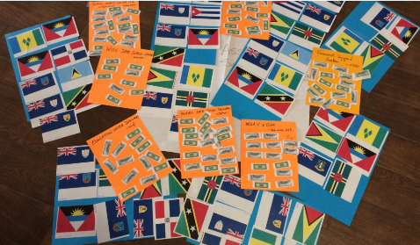
Annex IV: Market place - description of presented resource
The Market Place offer consisted of:
- Antigua and Barbuda Red Cross: Mega V & Open Data Kit (ODK)
- Caribbean Development Bank: Financial Support System
- CDEMA: Model Safe School Programme and Toolkit
- UNESCO: School Safety Assessment - VISUS Methodology
- UNICEF: Education Sector Indicators
- UNISDR: Worldwide Initiative for Safe Schools – Safe School Leader
- USAID/OFDA: School Safety Course (SSC)

Antigua and Barbuda Red Cross: Mega V & Open Data Kit (ODK)
At present, following an emergency, assessments are conducted using mostly pen and paper, which requires for results to be collected, transcribed and sent via phone, fax, mail or other means. During emergency response, this can result in a significant delay, ranging from a few hours to days or weeks.
ODK is a data collection tool which allows for electronic surveys to be designed and uploaded to a server. These surveys can be accessed and answered through any mobile device and the result uploaded. As a consequence, accurate information can be made available instantly online, reducing response times. Alternatively, data can be collected with the mobile devices offline, and uploaded at a later time.
ODK is the result of a merger of several “open source” tools, which run on Android devices for free, using simple interfaces. Creating a survey and loading it to a mobile device and collecting information doesn’t require extensive computer training.
The system allows for the identification of individuals or households, using a barcode. Therefore, it has become widely popular for mass distributions, allowing for humanitarian aid to arrive at the beneficiary in a timely, efficient, transparent and accountable manner. These uses can be explored beyond relief distributions.
Following the Marketplace presentations, representatives from the following countries showed interest in receiving more information: Antigua and Barbuda, British Virgin Islands, Dominica, Guyana, and Saint Vincent and the Grenadines.

Caribbean Development Bank: Financial Support System
Please add short description of the Financial Support System.

CDEMA: Model Safe School Programme and Toolkit for CDEMA Participating States
The Model Safe School Programme (MSSP) and Toolkit for CDEMA Participating States has been designed to support the mainstreaming of Comprehensive Disaster Management (CDM) into Caribbean schools. It expands the understanding of school safety beyond the traditional singular focus on emergencies to promote a comprehensive and holistic treatment of risk in the school environment. The MSSP approach is congruent with the Comprehensive School Safety Framework (CSS).
The Model features a policy, programme and standards organised around two broad approaches to addressing risk in schools: (i) a Safety Approach and (ii) a Green Approach (Table 1). For each approach, there are a number of strategic themes under which the standards for school safety have been articulated. The standards provide a benchmark for assessing how safe a school is and the assessment process allows for action planning and prioritization of interventions at the national and school levels. The MSSP is therefore also a support tool for decision-making in the education sector.
The MSSP Toolkit comprises a suite of standards, guidance documents, templates and other resources to support countries in implementing the programme. The resources in the Toolkit include:
- A Model Safe School Policy,
- A set of comprehensive standards for school safety and “greening”,
- Assessment tools for the Safety and “Green” standards and guidance on application of the tools,
- An assessment tool for building conditions,
- A Model School Disaster/Emergency Management Template
- A Model Safe School Certification Process.
The MSSP is a flexible resource for school administrators and Ministries of Education (MOE) which can be adapted, wholly or in part, to the individual country’s context.
Following the Marketplace presentations, representatives from the following countries showed interest in receiving more information: Anguilla, Dominica, Dominican Republic, Guyana, Montserrat, Saint Kitts and Nevis, Saint Lucia, Saint Vincent and the Grenadines, and Turks and Caicos.

UNESCO: School Safety Assessment - VISUS Methodology
VISUS assesses schools in a holistic and multi-hazard manner that considers five issues: site conditions, structural performance, local structural criticalities, non-structural components and functional aspects. Each issue is analysed using the process of an expert reasoning, splitting the assessment in two main phases: the characterization and the evaluation. As a result, simple graphical indicators summarise the evaluation pointing out the main weaknesses and the needs of intervention. The collection of data during the characterization phase is done through a mobile application.
The information generated will support the sustainability of the desired impacts as, i) Ministries of Education and Finance will be able to define and prioritize the budgets needed for future investments; and, ii) international and regional development banks can use the outcomes of the assessments to guide the design of future grants and loans for rehabilitation, reinforcement and retrofitting of school buildings, and in the construction of new safe schools.
Technical triage assessments and expert judgment pre-codification processes are the two main elements on which VISUS methodology is based.
Different levels of assessment can be identified aiming to answer different requirements. Low assessment levels are usually implemented through a collection of data (desk analysis, questionnaires, forms, check-lists, etc.). These approaches allow a quick ranking of buildings through indices. Nevertheless, such approaches cannot be detailed enough to properly answer all of the administrator’s concerns; and in most of the cases the quality of input data is not accurate. On the other hand, deeper analyses can answer the majority of administrator’s concerns, with in-depth/specific assessments, detailed design and cost quantification. However, these inspections are very costly, timely consuming and they rely on the available expertise within the country – which sometimes is inexistent – limiting the number of facilities that could be inspected.
Following the Marketplace presentations, representatives from the following countries showed interest in receiving more information: Anguilla, Antigua & Barbuda, Cuba, Dominica, Dominican Republic, Guyana, Montserrat, Saint Kitts and Nevis, Saint Lucia, Saint Vincent and the Grenadines, Turks and Caicos, and Virgin Islands.

UNICEF: Education Sector Indicators
The Education Sector Indicators have been developed to support the ministries of education of Latin America and Caribbean countries, through an analysis methodology whose objective is to provide quantitative and qualitative information on the state of performance and institutionalisation of disaster risk management within the education sector. Furthermore, it facilitates measuring the progress made implementing disaster risk management commitments taken on by ministries of education and other actors. Also, it allows to set quantifiable objectives for disaster risk management in the education sector.
At the same time, the Education Sector Indicators allow to review the policies, programmes, plans, methodologies and other tools developed and/or implemented by ministries of education from a risk management perspective. The framework lays out the various risk management spheres of action, allowing to disaggregate the analysis, which in turn shows if advancements in risk management in the education sector relates to all or only some (and which) of the following components: Risk Identification; Risk Reduction; Disaster Response; Recovery; and Financial Protection.
The tool is composed of 22 indicators and 79 verifiers, articulated in 11 thematic areas, which represent the spectrum of responsibilities and tasks of a Ministry of Education. The thematic areas are: Enabling Environment; Coordination; Curriculum; Extracurricular activities and community participation; Teachers; Educational Supplies and Resources; Quality Education; Financing; Infrastructure; Education Information Systems; and Disaster Impact.
UNICEF LACRO agreed to translate the tool into English, to be shared with countries form the Caribbean region.
Following the Marketplace presentations, representatives from the following countries showed interest in receiving more information: Anguilla, Antigua and Barbuda, British Virgin Islands, Cuba, Dominica, Dominican Republic, Guyana, Montserrat, Saint Kitts and Nevis, Saint Lucia, and Turks and Caicos.

UNISDR: Worldwide Initiative for Safe Schools – Safe School Leader
The Worldwide Initiative for Safe Schools (WISS) is a government-led global partnership that aims at securing political commitment and fostering safe school implementation globally. The Initiative is coordinated by UNISDR and was developed in collaboration with key partners from the Global Alliance on Disaster Risk Reduction Education and Resilience in the Education Sector as a response to the High-Level Dialogue Communiqué at the 2013 Global Platform for Disaster Risk Reduction.
WISS motivates and supports governments to develop and implement national school safety policies, plans and programs in combination with the three technical aspects of Comprehensive School Safety. The Worldwide Initiative offers technical assistance and particular expertise to support interested Governments in implementing Comprehensive School Safety at the national level, and promotes good practices and achievements in safe school implementation for replication in other countries and regions.
The Initiative also promotes good practices and achievements in safe school implementation for replication in other countries and regions, helps identify challenges and offers technical assistance and particular expertise around the three pillars to support interested Governments in implementing school safety at the national level.
A total of 35 of Governments have so far endorsed WISS: Algeria, Armenia, Bolivia, Brazil, Cambodia, China, Costa Rica, Croatia, Ecuador, United Stated, The Philippines, Finland, Georgia, Honduras, Indonesia; Italy, Iran, Japan, Kazakhstan, Kirghizstan, Lao, Lebanon, Madagascar, Mexico, Nepal, Nigeria, Panama, Paraguay, Qatar, South Africa, Saint Vincent and the Grenadines, Thailand, Tunisia, Turkey, and Turkmenistan.
Governments interested and active in promoting safe schools are invited to become Safe School Leaders as part of the WISS programme.
Following the Marketplace presentations, representatives from the following countries showed interest in receiving more information: Anguilla, Antigua and Barbuda, British Virgin Islands, Cuba, Dominica, Dominican Republic, Guyana, Montserrat, Saint Kitts and Nevis, Saint Lucia, Saint Vincent and the Grenadines, and Turks and Caicos.

USAID/OFDA: School Safety Course (SSC)
The course is aimed at qualified education authorities, teachers and administrative staff of schools, parents, public officials and staff from NGOs whose mission is related or may relate to risk prevention and mitigation and emergency preparedness and response in schools. It will provide participants with the knowledge and skills required to guide the promotion, design, development and systematization of safety plans for schools.
Upon completion of the course participants will be able to: describe the concepts of emergency, disaster and adverse event; explain risk and its factors; list useful resources for risk management; explain the importance of knowing the risks and the resources; describe the areas and components of risk management; list five reasons supporting the role of education in risk management; describe the objectives and scope of the School Safety Plan; explain the key activities to promote and implement a School Safety Plan; identify the benefits of emergency management preparedness in schools; and identify the differences between simulations and drills, in situations observed during course exercises.
Following the Marketplace presentations, representatives from the following countries showed interest in receiving more information: Anguilla, Antigua and Barbuda, Dominica, Dominican Republic, Montserrat, Saint Kitts and Nevis, Saint Lucia, Saint Vincent and the Grenadines, and Turks and Caicos.

Annex V: Detailed agenda
Time | Monday, April 3rd, 2017
08:00-09:00 | Registration
09:00-09:30 | Opening ceremony  Representatives from regional organizations, the Minister of Education, Science and Technology of Antigua and Barbuda as well as other national delegates delivered welcome & opening remarks.
09:30-09:45 | Break for group photo and media interviews with panelists
09:45-10:00 | Introduction to the Forum  Presentation of Forum objectives, expected outcomes, agenda, working methodology and provision of logistical information  - Marcel GOYENECHE, Facilitator
10:00-10:40 | Comprehensive School Safety Framework – Global and regional progress  Introduction of existing global and regional initiatives and achievements related to disaster risk reduction and its integration within the education sector  Moderator:  - Idelia FERDINAND, Ministry of Education, Saint Vincent and the Grenadines  Speakers:  - Sendai Framework for Disaster Risk Reduction and Worldwide Initiative for School Safety (WISS)  Sandra AMLANG, UNISDR  - Comprehensive School Safety Framework (CSS)  Jair TORRES, UNESCO  - Comprehensive Disaster Management (CDM) strategy, Model Safe School Programme and other achievements  Gayle DRAKES, CDEMA
10:40-11:00 | Coffee break
11:00-13:00 | Comprehensive School Safety Framework – Global and regional progress (continuation)
13:00-14:00 | Lunch
14:00-15:30 | School Safety in the Caribbean – Achievements, gaps and priorities at the national level  Ministries of Education presented the main achievements, challenges and priorities regarding school safety from their country’s perspective. Linkages were made to the three pillars of the Comprehensive School Safety Framework. Based on the information provided by each country, participants identified how to address main challenges and gaps by identifying top priorities.  Moderator of group results:  Elizabeth RILEY, CDEMA
15:30-16:00 | Coffee break
16:00-17:30 | Discussion on Caribbean Declaration on School Safety  Ministers and high-level authorities continued the dialogue surrounding the content of the ‘Antigua and Barbuda Declaration on School Safety in the Caribbean’, finalizing the wording of the Declaration.  Chair:  - Hon. Michael BROWNE, Ministry of Education, Science and Technology, Antigua and Barbuda
17:30-18:00 | Endorsement and signing of Declaration  Ministers and high-level authorities signed the ‘Antigua and Barbuda Declaration on School Safety in the Caribbean’.  Master of Ceremony:  - Elizabeth RILEY, CDEMA
19:00-20:00 | Cocktail reception hosted by Antigua and Barbuda

Time | Tuesday, April 4th, 2017
08:30-09:00 | Recap  Brief recap of the previous day’s main topics
09:00-10:00 | Tsunami preparedness – Relevance for the education Sector  Presentations by experts on tsunami preparedness, highlighting the relevance for the education sector. Forum participants were provided with an overview on progress being made in the Caribbean regarding tsunami preparedness and of public awareness-raising and education strategies.  Moderator:  - Jair TORRES, UNESCO  Speakers:  - Tsunami hazard in the Caribbean  Dr. Silvia CHACON, Costa Rica  - Intergovernmental Coordination Group for the Tsunami and other Coastal Hazards Warning System for the Caribbean and Adjacent Regions (ICG/CARIBE EWS)  Paul MARTENS, Sint Maarten, Kingdom of Netherlands  - Saint Kitts & Nevis experience on Tsunami Readiness  Claricia LANGLEY-STEVENS, National Emergency Management Agency (NEMA), Saint Kitts & Nevis  - Tsunami Public Awareness & Education (PAE) Strategy for the Caribbean and Adjacent Regions, Jair TORRES, UNESCO
10:00-  10:45 | Marketplace: Existing products and support by international organizations / donors to enhance school safety  Regional partners shared with Ministries of Education existing areas for technical support by showcasing tools, products and services that raise awareness on school safety, strengthen capacities in a country or school or facilitate decision-making regarding school safety. Ministries could prioritize and purchase tools, products and services that they feel would be most relevant to enhance school safety in the respective country at this time.
10:45-11:00 | Coffee Break
11:00-13:00 | Regional Road Map for School Safety  Building upon the safe school priorities identified the previous day, participants collectively agreed upon the main regional priorities aligned to the Comprehensive School Safety Framework (CSS). Working in groups, one for each of the three CSS pillars, participants identified concrete and achievable activities for each of the regional priorities, while also defining the timeframe, key actors and required technical and financial support.
13:00-14:00 | Lunch
14:00-15:00 | Regional Road Map for School Safety  The three groups presented their respective results and peers provided comments and inputs to the elements identified for each priority area.  Chair:  - Ministry of Education, Science and Technology, Antigua and Barbuda
15:00-15:30 | Caribbean Safe School Initiative (CSSI)  The Caribbean Safe School Initiative provides a frame for the future activities to be implemented in Caribbean region regarding school safety over the coming years. The ‘Antigua and Barbuda Declaration on School Safety in the Caribbean’ and the ´Regional Road Map for School Safety´ provide details on the priorities as agreed upon by Ministries of Education in the Caribbean.  Chair:  - Ministry of Education, Science and Technology, Antigua and Barbuda
15:30-16:00 | Coffee break
16:00-17:00 | Launch of the Caribbean Safe School Initiative (CSSI)  Official launch of the Caribbean Safe School Initiative followed by closing remarks. Ministries of Education provided with a signed copy of the ‘Antigua and Barbuda Declaration on School Safety in the Caribbean’.

Annex VI: Participants list
Country | Name | Titel | Organisation
Anguilla | Rhonda Connor | Chief Education Officer | Education Department
Antigua and Barbuda | Hon. Michael S. Browne | Minister | Ministry of Education, Science and Technology
Antigua and Barbuda | Rosa Greenaway | Permanent Secretary | Ministry of Education, Science and Technology
Antigua and Barbuda | Clare L. Browne | Director of Education | Ministry of Education, Science and Technology
Antigua and Barbuda | Dr. Patricia George-Benfield | Deputy Director of Education | Ministry of Education, Science and Technology
Antigua and Barbuda | Beverly Allen | Assistant Director of Education, Curriculum | Ministry of Education, Science and Technology
Antigua and Barbuda | Stacey Payne-Mascall | Assistant Director of Education - Planning, Services, Research and Training | Ministry of Education, Science and Technology
Antigua and Barbuda | Rolston Nickeo | Education Officer, Focal Point for School Safety in Schools in Antigua | Ministry of Education, Science and Technology
Antigua and Barbuda | Mervin Browne | Projects Officer - Board of Education | Ministry of Education, Science and Technology
Antigua and Barbuda | Jeannette Mason | Knowledge Base Officer | Ministry of Education, Science and Technology
Antigua and Barbuda | Melville Richardson | Education Officer – Visual Arts/Art and Deputy Co-coordinator, Planning of Caribbean Safe Schools Ministerial meeting | Ministry of Education, Science and Technology
Antigua and Barbuda | Vidal Young Romero | Education Officer – Modern Languages - Translator | Ministry of Education, Science and Technology
Antigua and Barbuda | Karen Wilkins | Head of Meeting Secretariat | Ministry of Education, Science and Technology
Antigua and Barbuda | Kanisha Bright | Secretariat | Ministry of Education, Science and Technology
Antigua and Barbuda | Alicia Harrigan-James | Secretariat | Ministry of Education, Science and Technology
Antigua and Barbuda | Tamara Simon | Secretariat | Ministry of Education, Science and Technology
Antigua and Barbuda | Monica Phillip-Simon | Secretariat | Ministry of Education, Science and Technology
Antigua and Barbuda | Nadine Roberts | Secretariat | Ministry of Education, Science and Technology
Antigua and Barbuda | Phil George | Communications Officer/Media | Ministry of Education, Science and Technology
Antigua and Barbuda | Philmore Mullin | Director | National Office of Disaster Services
Antigua and Barbuda | Jeff Lawrence | Force Sergeant Major | Antigua and Barbuda Defence Force
Antigua and Barbuda | Nuffield Burnette | Assistant Commissioner of Police | Royal Police Force of Antigua and Barbuda
Antigua and Barbuda | Elvis Weaver | Assistant Commissioner of Police | Fire Police
Antigua and Barbuda | Elvis Murray Watkins | Director General | Antigua and Barbuda Red Cross Society
Barbados | Elizabeth Riley | Deputy Executive Director | CDEMA
Barbados | Gayle Drakes | Education and Training Specialist | CDEMA
Barbados | Unai Sacona | Education Manager | UNICEF
Barbados | Elaine King | Adolescent Development Specialist | UNICEF
Barbados | Paul Murphy | Education Specialist | Caribbean Development Bank
Barbados | Dwayne Squires | Engineer | Caribbean Development Bank
Chile | Marcel Goyeneche | Facilitator | Independent Consultant
Costa Rica | Dr Silvia Chacon | Chair | ICG/CARIBE EWS WG on Tsunami Hazard Assessment
Cuba | H. E. Gustavo Veliz Olivares | Ambassador of the Republic of Cuba | Embassy of the Republic of Cuba in Antigua and Barbuda
Cuba | Kissy Gomes |  | Embassy of the Republic of Cuba in Antigua and Barbuda
Cuba | Alfonso Clovis Núñez Leguen | Advisor | Ministry of Education
Dominica | Melena Fontaine | Chief Education Officer | Ministry of Education and Human Resource Development
Dominican Republic | José Miguel Martinez Guridy | Director del Departamento de Gestión de Riesgos | Ministry of Education
France | Jair Torres | Disaster Risk Reduction and Resilience Officer | UNESCO
Guyana | Marcel Hutson | Chief Education Officer | Ministry of Education
Guyana | Cecil Shillingford |  | USAID OFDA
Jamaica | Barbara Carby | Director of the Disaster Risk Reduction Center | University of West Indies
Jamaica | Katherine Grigsby | Director and Representative | UNESCO Kingston Cluster Office for the Caribbean
Montserrat | Hon. Delmaude Ryan | Minister | Ministry of Education, Youth Affairs & Sports
Montserrat | Glenn Francis | Acting Permanent Secretary/Director of Education | Ministry of Education, Youth Affairs & Sports
Panama | Sandra Amlang | Programme Officer | UNISDR
Panama | Ruth Custode | Regional Education Specialist | UNICEF
Saint Kitts and Nevis | Hon. Shawn Richards | Minister | Ministry of Education
Saint Kitts and Nevis | Eleanor Phillip | Senior Assistant Secretary in the Ministry of Education | Ministry of Education
Saint Kitts and Nevis | Claricia Langley-Stevens | Deputy National Disaster Coordinator | National Emergency Management Agency (NEMA)
Saint Lucia | Hon. Gale T.C. Rigobert | Minister | Ministry of Education, Innovation, Gender Relations and Sustainable Development
Saint Lucia | Kendall Khodra | Deputy Chief Education Officer - Planning | Ministry of Education, Innovation, Gender Relations and Sustainable Development
Saint Lucia | Yoshabel Durand | Research Officer, Social Development Unit | OECS Commission
Saint Lucia | Crispin D'Auvergne | Climate Change and Disaster Risk Management Coordinator | OECS Commission
Saint Vincent and the Grenadines | Hon. Senator Deborah Alexander-Charles | Parliamentary Secretary | Ministry of Education, Reconciliation and Ecclesiastical Affairs
Saint Vincent and the Grenadines | Dr. Idelia Ferdinand | Education Officer with responsibility for School Safety | Ministry of Education, Reconciliation and Ecclesiastical Affairs
Sint Maarten, Kingdom of Netherlands | Paul Martens | Vice-Chair ICG/CARIBE EWS and Head Section Disaster Management | Disaster Management Section
Turks and Caicos Islands | Hon. Josephine Connolly | Minister | Ministry of Education, Youth, Sports, Culture and Library Services
Turks and Caicos Islands | Edgar Howell | Director of Education | Ministry of Education, Youth, Sports, Culture and Library Services
Virgin Islands | Hon. Myron Walwyn | Minister | Ministry of Education and Culture
Virgin Islands | Marcia Potter | Permanent Secretary | Ministry of Education and Culture
Virgin Islands | Evangeline Inniss-Springer | Deputy Director | Department of Disaster Management

Up to April 2017

