ABC for Articles and Press Releases

A. Both articles and press releases are generated around a story that contains achievements, statements, alerts, political positions or relevant figures that occur in the context of a special event (planned or unplanned).  B. Ideally, they address a main idea that is presented in the first paragraph* (if the media cuts the story, the main idea remains). The most important information should be included in the first paragraph to grab the reader's attention.  To choose a main idea among the wealth of information available, select one of the following as the most important question to answer:  ¿What, how, when, where, who, why?  And then build a pyramid (the most important at the top) answering the other questions throughout the body of the text with supporting figures, opinions (quotes), contextual data and a conclusion.  C. The language and terminology used need to be clear and simple so that the general public can grasp the main idea and relevant information.  Other writing tips include:  - Maximum length of 700 words  - Short sentences of 25 to 30 words and paragraphs with up to four sentences.  - Names of institutions + (ACRONYMS) denoted in the first reference, followed by ACRONYM only for subsequent references  Example: National Office of Emergencies of the Ministry of Interior and Public Security, ONEMI  - Proper names in bold  Example: Margareta Wahlström  - Additional information such as photos**, related articles and technical definitions with links, either within the text of the document or at the end as “Related links”.  Example: …Hyogo Action Framework 2005-2015, MAH  Related links  “Orange Day” event photos  Links about press releases:  - 10 ideas for writing effective press releases  - 10 ways to make your press release SEO friendly  - How to write an announcement or press release  - How to prepare a good press release  - The structure of a press release | Examples:  An event related to the Global Campaign is not news in itself (the media must choose between thousands of events to report. The news lies in the final results of the meeting such as the agreements reached, municipalities added to the campaign, the official expression of support for the campaign or a context of recent disasters in the country where the event is taking place.  In the ‘Regional Workshop on Planning for Disaster Recovery’ the main idea can be THAT in Central America, there are disaster action plans, instead of where or when the meeting took place.  However, in the Regional Consultation Forum ‘Understanding Public investment for Comprehensive Disaster Risk Management’, the news is WHO during their speech (the representative of the government of Mexico) recognizes that the UNISDR promotes a smart policy for public investment in disaster risk.  Tips:  * The first paragraph is usually the last to be constructed to ensure that it contains all of the important information in the text.  **It is highly recommended to include a group photo.  *** All photos must include a photo caption indicating who appears and in what context.  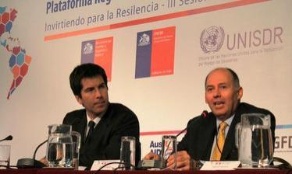  BBenjamín Chacana, ONEMI, and Ricardo Mena, UNISDR.

