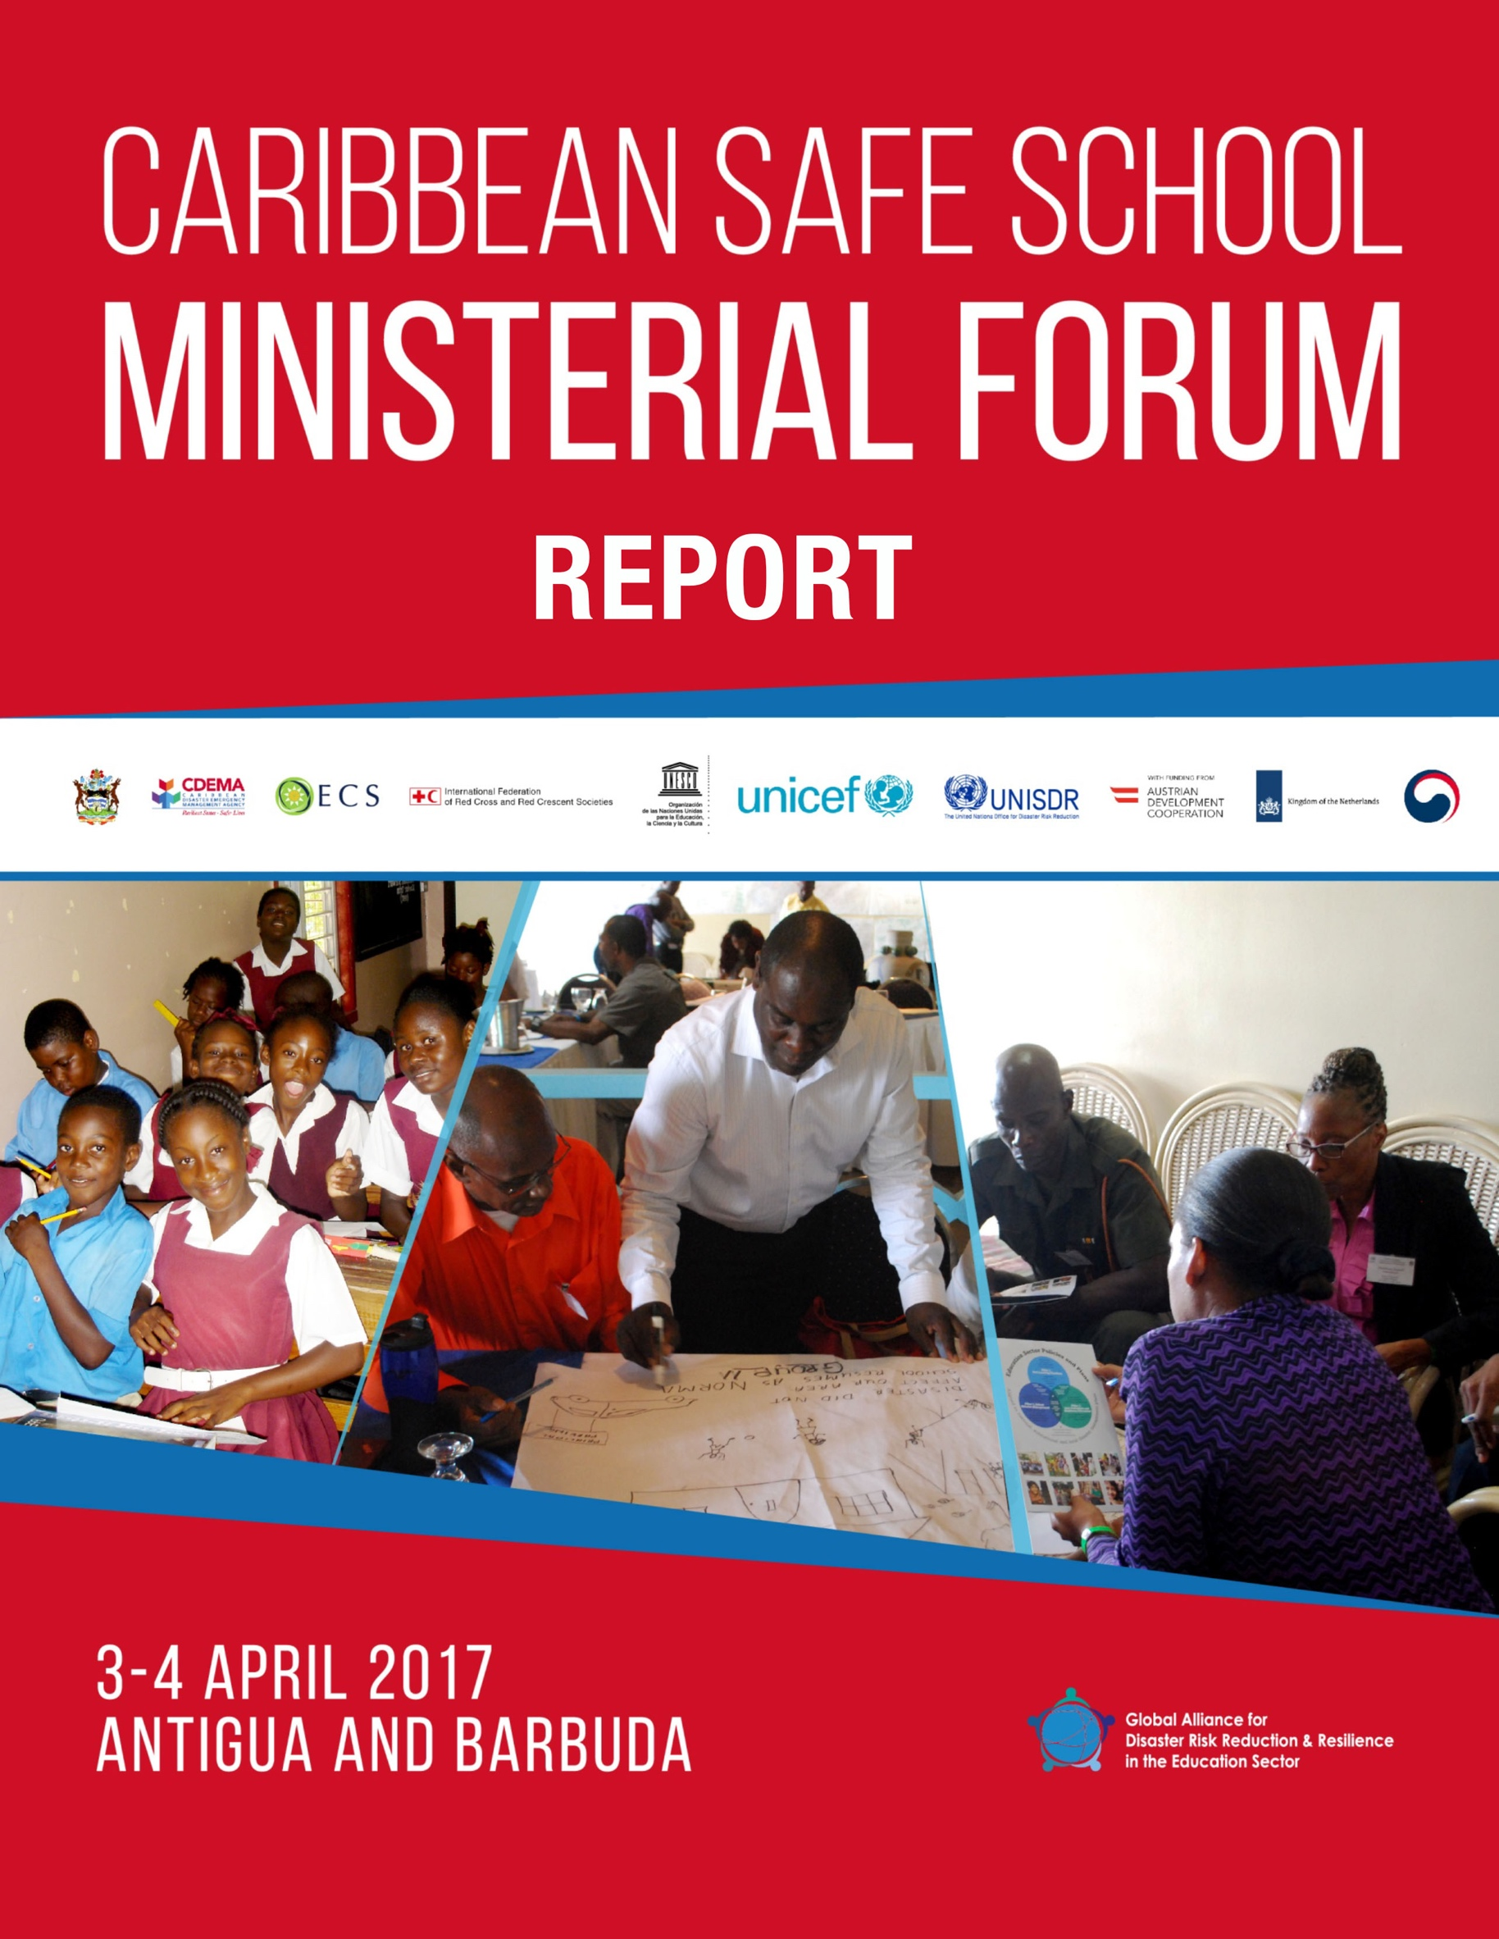

Table of Contents
Acknowledgements 4
1. Executive summary 5
2. Introduction 9
3. Caribbean Safe School Ministerial Forum 10
3.1. Objectives 11
3.2. Outcomes 11
3.3. Participants 11
3.4. Methodology 11
4. School Safety achievements & challenges in the Caribbean 12
4.1. National achievements & challenges 12
4.2. Regional achievements & challenges 13
5. Antigua and Barbuda Declaration on School Safety in the Caribbean 14
6. Regional Road Map for School Safety 15
6.1. Regional Priorities to be included in the Regional Road Map for School Safety 15
6.2. Other regional priorities 16
6.3. Resources from partners 18
6.3.1. Tsunami preparedness – Relevance for the education sector 18
6.3.2. Market place 19
7. Caribbean Safe School Initiative 20
8. Conclusions 21

List of Acronyms

ADA Austrian Development Agency
CCA Climate Change Adaptation
CDB Caribbean Development Bank
CSS Comprehensive School Safety
CSSI Caribbean Safe School Initiative
CDM Comprehensive Disaster Management
CDEMA Caribbean Disaster Emergency Management Agency
CHC Coordination and Harmonization Council
CWP Country Work Programme
DRR Disaster Risk Reduction
GADRRRES Global Alliance for Disaster Risk Reduction and Resilience in the Education Sector
ICG/CARIBE EWS Intergovernmental Coordination Group for the Tsunami and other Coastal Hazards Warning System for the Caribbean and Adjacent Regions MSSP
SDGs Sustainable Development Goals
SFDRR Sendai Framework for Disaster Risk Reduction 2015-2030
UNICEF United Nations Children's Fund
UNISDR United Nations Office for Disaster Risk Reduction
UNESCO United Nations Educational, Scientific and Cultural Organization
USAID/OFDA United States Agency for International Development / Office of United States Foreign Disaster Assistance
WISS Worldwide Initiative for Safe Schools

Acknowledgements
The Caribbean Safe School Ministerial Forum took place from 3 to 4 April 2017 in Antigua and was hosted by the Ministry of Education, Science and Technology in Antigua and Barbuda.
The Forum was jointly organized by the Ministry of Education, Science and Technology in Antigua and Barbuda, the Caribbean Disaster Emergency Management Agency (CDEMA), the United Nations Office for Disaster Risk Reduction (UNISDR), the United Nations International Children's Emergency Fund (UNICEF), United Nations Educational, Scientific and Cultural Organization (UNESCO), the International Federation of Red Cross and Red Crescent Societies (IFRC) and the Organization of Eastern Caribbean States (OECS) thanks to the financial support by the Austrian Development Agency, the Kingdom of the Netherlands as well as the Republic of Korea.
Special thanks goes to the Ministry of Education for its leadership in the preparation of the Forum and beyond as well as the organization team mentioned above.
In addition, the efforts of the participating Ministries of Education with support of the National Disaster Management Offices needs to be acknowledged. Ministries were invited to identify prior to the Forum national achievements, gaps and priorities regarding schools safety which were crucial for the development of the regional Road Map for School Safety.
Last but not least, we acknowledge all participants for contributing actively to the success of the Forum.
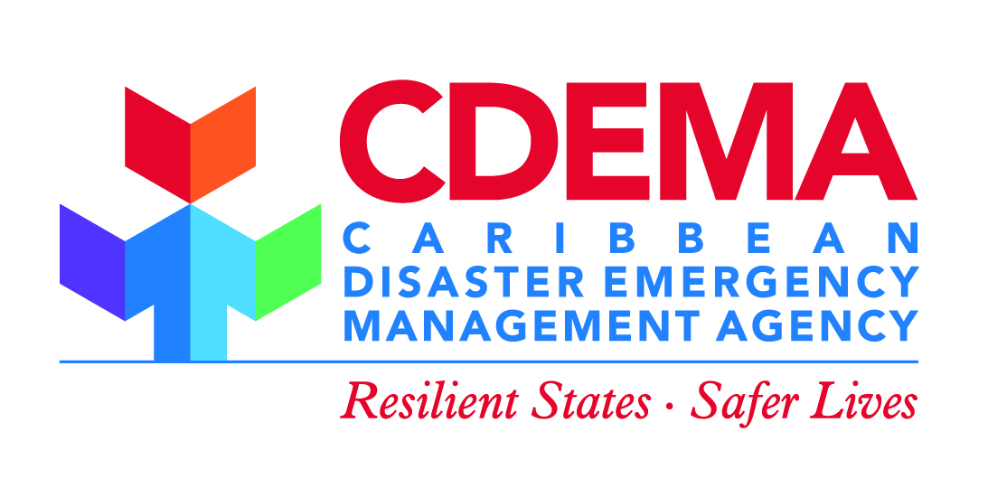
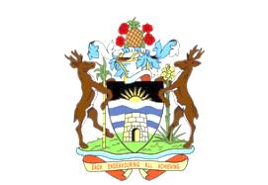

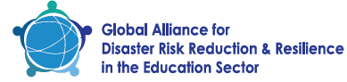
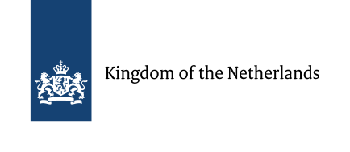
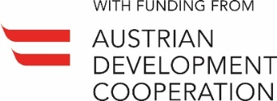
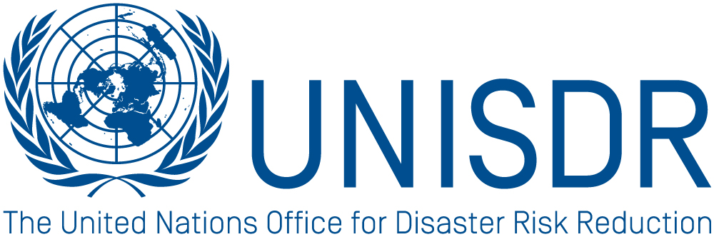
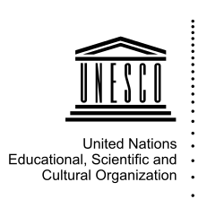

Executive summary
Education plays a crucial role in reducing vulnerability and building community resilience to disaster risks. Furthermore, it is also essential for empowering people and reducing poverty. Damage to schools by disasters can lead not only to the loss of children’s and teachers’ lives but also to a loss of public investment in social infrastructure and interruptions to education, which in turn can have lifelong implications. The need to keep schools safe has been reflected in the the 2030 Agenda for Sustainable Development adopted by the 193 countries, as well as the Sendai Framework for Disaster Risk Reduction. Through these, the education sector is compelled to provide a safe and effective learning environment, building disaster-resistant structures according to local risks, while at the same time calling for knowledge and awareness of hazards and risk to be part of the school curriculum in order to bring about behavioral changes that support disaster risk reduction and greater resilience.
For this purpose, the Worldwide Initative for Safe Schools (WISS) seeks to motivate and support Governments to develop national strategies and implement school safety, building upon the Comprehensive School Safety Framework (CSS) and defining a safe school as one that combines all of the following elements: Safe Learning Facilities (disaster-resilient infrastructure); School Disaster Management; and Disaster Risk Reduction and Resilience Education. These make up the three core pillars of CSS, which should be addressed by education policies and plans, and aligned with disaster management at national, regional, district, and local school site levels.
In the Caribbean, the Comprehensive Disaster Management (CDM) Strategy 2014-2024 is the strategic road map for disaster risk management. Specifically, Priority Area 2 of the Strategy aims to achieve “Increased and sustained knowledge management and learning for Comprehensive Disaster Management”. The Strategy also seeks to advance the integration of DRM into seven priority sectors of which the Education is one. Among the previous experiences in the Caribbean seeking to address the three pillars of the CSS Framework are: the Living Schools Project; the Caribbean Model Safe School Programme (MSSP) and Toolkit and the Disaster Risk Reduction (DRR) Education Toolkit.
The Caribbean Safe School Ministerial Forum, hosted by the Ministry of Education, Science and Technology of Antigua and Barbuda, took place from 3 to 4 April 2017 in Antigua aiminged at further advancing school safety in the region. For this purpose, the Forum was the platform for the launch of the Caribbean Safe School Initiative (CSSI), the suggested framework to advance school safety in the Caribbean. The CSSI is the Caribbean contribution to the WISS and shall be a partnership for advancing safe school implementation at the national level among Caribbean countries. Ministries of Education will lead the implementation supported by international, regional and national partners.
The political commitment to the CSSI is provided by the Antigua and Barbuda Declaration on School Safety. The Declaration underwent a consultation process prior the Forum, with active participation of attending countries. The representatives’ persistent commitment allowed for the final version of the Declaration to be produced and agreed upon during the event itself. Consequently, the Forum achieved the Declaration’s endorsement by all attending representatives, namely: Antigua and Barbuda, Anguilla, Dominica, Dominican Republic, Cuba, Guyana, Montserrat, Saint Kitts and Nevis, Saint Lucia, Saint Vincent and the Grenadines, Turks and Caicos, Virgin Islands.
The key commitments contained in the Declaration are:
- Engage in the multi-stakeholder "Worldwide Initiative for Safe Schools (WISS)", by supporting the implementation of the Comprehensive Safe School Framework and the Model Safe School Programme in the Caribbean for public and private facilities at all levels.
- Build resilience in the education sector.
- Source financial and other resources from the national, regional, and the international community, from public and private sectors, to be channeled towards strengthening efforts in DRR linked to the education sector.
- Coordinate with national and regional disaster management bodies to integrate the tenets of Comprehensive Disaster Management (CDM) into education policies and plans and to ensure alignment with existing national and regional disaster risk reduction and climate change resilience building strategies.
- Strengthen the coordination and cooperation mechanisms among stakeholders at the community, national, regional and international levels.
- Build stronger collaboration among the Ministries of Education in the Caribbean with relevant private sector entities, non-governmental organisations as well as other regional and international entities.
- Define and put in place a framework to track and measure progress on the implementation of the actions identified in the Road Map on School Safety to be authorized by the Minister of Education.

Through paralell consultations in the weeks ahead of the Forum and individual presentations during the event, countries put forward their unique national achievements, challenges and priorities. In turn, plenary and peer-to-peer discussions, using the Comprehensive School Safety Framework to guide the dialogue and analysis, these issues were evolved, enabling participants to identify joint regional achievements, challenges and priorities. These priorities are also the basis for the Regional Road Map for School Safety.
The main identified regional priorities are:
Enabling Environment
- Develop enabling policies and national plans/strategies
- Human & financial resources
Pillar 1: Safe Learning Facilities
- Develop and implement a standardised school safety assessment
- Develop a safe school standard
Pillar 2: School Disaster Management
- Review and develop multi-hazard school safety plans and guiding documents
- Improved coordination among stakeholders led by the Ministry of Education
Pillar 3: Risk Reduction and Resilience Education
- Update and review disaster risk management components in curricula
- DRM training for school staff, families and community

The actions required to address these priorities are outlined in the Regional Road Map for School Safety, developed during the Forum. For each priority, representatives identified activities, timeframe, responbile organisation and required technical/financial support. Focus was given on concrete and pragmatic actions which lead to priorities being addressed and thus, advance school safety in the Caribbean in line with the commitments outlined in the Declaration. Activities included in the Road Map document refer both regional and national-level activities..
Finally, with the aim to create sinergies and demonstrate which technical support can be provided, partners presented specific resources and services which can support the implementation of school safety. These included Tsunami preparedness and its link to the education sector through existing awareness-raising initatives, as well as other resources such as the presentation of Mega V & Open Data Kit (ODK) by the Antigua and Barbuda Red Cross, the Model Safe School Programme and Toolkit by CDEMA, the School Safety Assessment - VISUS Methodology by UNESCO, Education Sector Indicators by UNICEF, the Worldwide Initiative for Safe Schools – Safe School Leader by UNISDR, the Financial Support System by CDB and the School Safety Course by USAID/OFDA.
Following the Forum, next steps will focus on advancing the CSSI, specifically agreeing on Terms of Reference for the Group of Ministers chaired in 2017 by the Minister of Education, Science and Technology in Antigua and Barbuda . Furthermore, other Caribbean countries will be invited to join the group and adhere to the Declaration. In addition, existing monitoring and reporting mechanisms and platforms such as the biannually organized CDM conference, Regional/Global Platform for Disaster Risk Reduction as well as the annual WISS meeting will be used to follow-up on commitment implementation. It was suggested that countries shall incorporate achievements at national level in the reporting against the CDM strategy (CDM Monitor) and the Sendai Framework for DRR (Sendai Monitor).
The next meeting of the Forum is scheduled for 2019 in Saint Vincent and the Grenadines. The organization team will explore possible funding opportunities in order to support the implementation of the Road Map and the CSSI together with development banks, such as the Caribbean Development Bank (CDB), the Inter-American Development Bank (IDB), and The World Bank, as well as with other interested donors and countries development agencies.
All Forum related documents are available here: http://eird.org/americas/safe-school-forum/
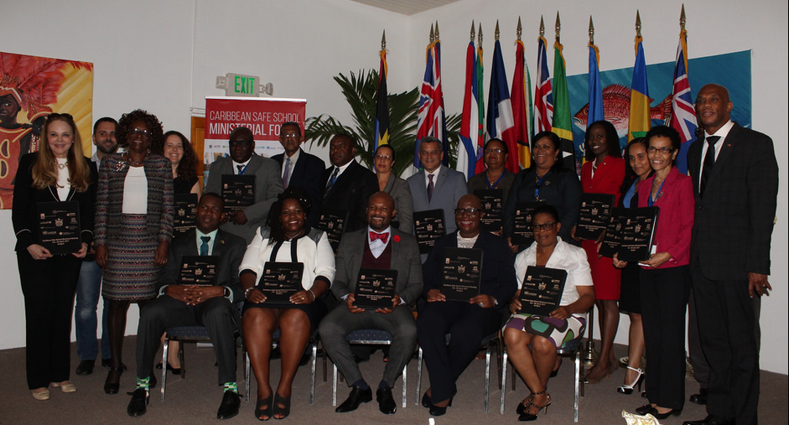

Introduction
Caribbean developing countries are exposed to a variety of similar natural hazards, namely hurricanes, floods, volcanic eruptions, earthquakes, tsunamis, landslides, droughts and fires. These hazards have compromised country’s poverty reduction strategies, hindered development gains and endangered educational systems and their impacts are likely to be magnified by the expected effects of changes in global climate and potentially more frequent and severe extreme weather events. Low-lying states in the Caribbean are especially vulnerable to these effects which pose significant risks to public safety, infrastructure and natural resources.
Disasters have a major impact on children, youth and education systems. Studies suggest that worldwide each year 175 million children are likely to be affected by natural disasters, and children in the Caribbean are no exception. In 2004, Hurricane Ivan caused widespread destruction in Grenada damaging 73 of 75 public schools. In 2010, in Haiti, a massive earthquake killed 38,000 students and 1,300 teachers and education personnel, and destroyed 4,000 schools as well as the headquarters of the Ministry of Education. These figures are likely to increase unless populations improve their capacity to anticipate, prepare, adapt and become more resilient to such events. Most countries however are small and resources are scarce or non-existent for each to carry out tasks on an individual basis. Despite this, major strategies have been implemented individually in different countries in order to improve school preparedness. Significant economies of scale however can be realized through a coordinated regional approach and efforts have been made in that regard. CDEMA has recently developed a Model Safe School Programme (MSSP) and Disaster Risk Reduction (DRR) Education Toolkit for Caribbean Schools. These initiatives speak to the three pillars of a Comprehensive School Safety (CSS) Framework, namely: safe learning facilities, school disaster management and risk reduction and resilience education.
The CSS Framework was developed by the Global Alliance for Disaster Risk Reduction and Resilience in the Education Sector. UNESCO, UNICEF, United Nations Office for Disaster Risk Reduction (UNISDR), International Federation of Red Cross and Red Crescent Societies and non-governmental organizations committed to DRR (such as Save the Children, Plan International, among others) are part of that Alliance. They each possess different tools and experiences which support CSS, some of which are already in use in the region and could complement CDEMA’s initiatives. By example UNESCO’s Visual Inspection for defining the Safety Upgrading Strategies (VISUS) tool facilitates efficient, economical and effective infrastructural assessments necessary to providing safe learning facilities. And IFRC’s Protected School module and Public Awareness and Public Education (PAPE) for DRR guides support DM and DRR education.
In line with global recognition, the importance of school safety had also been long acknowledged in the Caribbean. As noted above, the 2014-2024 CDM Strategy for the Caribbean through its Priority Area 2 calls for increased and sustained knowledge management and learning for Comprehensive Disaster Management, as well as standardization and improvement of educational and training materials. Similarly, DRR Country Documents highlight the importance of increasing awareness on DRR as a main area to be addressed in the education sector at the country level.
In addition, political will for action was demonstrated by previous experiences in the Caribbean which have sought to address the three (3) pillars of the CSS inter alia:
- The Living Schools Project based on a concept developed by Brazil in 2010 and adapted by CDEMA for the Caribbean Environment;
- The Caribbean Model Safe School Programme (MSSP) and Toolkit developed by CDEMA in 2014 and implemented in three pilot countries (Anguilla, Barbados, Saint Vincent and the Grenadines);
- The Disaster Risk Reduction (DRR) Education Toolkit developed by CDEMA in 2014 and implemented in three pilot countries (St. Kitts and Nevis, and the Turks and Caicos).

In particular, the CDEMA MSSP comprises a set of standards for school safety, as well as a number of models, guidelines and tools which Ministries of Education and schools can use to design and implement a programme of comprehensive risk management at the school level. The MSSP was endorsed by the CDEMA Coordination Council in 2015 as the standard for school safety programmes in CDEMA. The standards contained in the MSSP address a broad spectrum of safety and greening issues which influence vulnerability in schools, incorporating climate change and environmental management considerations. The MSSP is congruent with the Global Alliance for Disaster Risk Reduction & Resilience in the Education Sector (GADRRRES) Actions to strengthen coordination, increase knowledge, and advocate on risk reduction education and safety in the education sector. The CDEMA Disaster Risk Reduction Education Toolkit is designed to aid teachers in integrating DRR into the existing curriculum. A recent Caribbean forum on integrating Disaster Risk Reduction in the Education sector was hosted by Saint-Lucia in October 2015 with the support of USAID/OFDA. This forum focused on DRR and Higher Learning Institutions, aiming at strengthening school safety and commitments towards the implementation of the three pillars of school safety. Good practices in terms of DRR in early childhood and higher education were presented. It created opportunities for networking and sharing good practices as various experts were invited from different backgrounds, such as academics, private sector, local governments and ministers of education of 10 countries who participated in this meeting.
Another milestone in the process of building a harmonious regional initiative has been the adoption of the Tsunami Public Awareness & Education (PAE) Strategy for the Caribbean and Adjacent Regions. This was the first time that a tsunami awareness and educational strategy of this scope and magnitude has been developed for this region. It was the result of over seven months of extensive research, analysis and consultation with over 30 stakeholders during 2012 and 2013. This process has been shown the potential to coordinate actions between different stakeholders and technical partners in the region, as may be use as a good practice to be enlarged to a multi-hazard perspective in the framework of a potential Caribbean Safe School Initiative, In May of 2015, UNESCO in cooperation with the Ministry of Education, Science and Technology in Antigua and Barbuda organized the first training programme on CSS and Education Sector Policies and Plans. Fifty educational planners from fourteen Caribbean countries attended and requested further support for implementing concrete actions on the different areas of CSS. This Safe School Forum in the Caribbean region is an initial response to that request, and to the need for a collaborative and coordinated approach among actors in the region’s education sector. It will contribute to: CDEMA’s Regional Comprehensive Disaster Management (CDM) Strategy and Programming Framework 2014-2024; UNISDR’s Worldwide Initiative for Safe Schools (WISS); the Samoa Action Plan for SIDS, the Global Action Programme on Education for Sustainable Development; the Sendai Framework for Disaster Risk Reduction 2015-2030, and to the 2030 Agenda for Sustainable Development.

Caribbean Safe School Ministerial Forum
The Caribbean Safe School Ministerial Forum was hosted by the Ministry of Education, Science and Technology of Antigua and Barbuda from 3 to 4 March 2017 in Antigua. This Forum has been organized by the Ministry in close collaboration with the Caribbean Disaster Emergency Management Agency (CDEMA), the United Nations International Children's Emergency Fund (UNICEF), the United Nations Office for Disaster Risk Reduction (UNISDR), United Nations Educational, Scientific and Cultural Organization (UNESCO) and the International Federation of Red Cross and Red Crescent Societies (IFRC) and the Organization of Eastern Caribbean States (OECS).

Objectives
1) Promote and raise awareness on the three pillars of School Safety of the Worldwide Initiative on Safe Schools (WISS) in the Caribbean.
2) Identify national and joint regional achievements and priorities regarding School Safety.
3) Ministers of education validate and adopt the Caribbean Declaration and Road Map on School Safety, and commit to its implementation.

Outcomes
1) Awareness on the three pillars of school safety and WISS raised.
2) National and regional priorities regarding school safety identified.
3) Caribbean Declaration on School Safety approved and signed.
4) Caribbean Safe School Initiative launched.

Participants
Given the Forum’s focus on ministries of education, attendees included ministers or their representatives as well as technical advisors. A total of 60 participants attended the Forum, including 18 representatives from Antigua and Barbuda, Cuba, Dominica, Dominican Republic, Guyana, Montserrat, Saint Kitts and Nevis, Saint Lucia, Saint Vincent and the Grenadines, Turks and Caicos, and the British Virgin Islands.
Furthermore, regional organizations with capabilities to support the implementation of the CSSI also attended the Forum. These included the Caribbean Development Bank, CDEMA, ICG/CARIBE EWS, OECS Commission, UNESCO, UNICEF, UNISDR, University of West Indies, and USAID/OFDA.
Local organizations who attended or supported the forum are the National Office for Disaster Service (NODS), Fire Police, the Antigua and Barbuda Red Cross Society, and the Royal Police Force of Antigua and Barbuda.

Methodology
The Forum and its agenda was articulated around the Comprehensive School Safety Framework, which acted as the guiding tool throughout the event. Therefore, its three Pillars were a key element for shaping discussions, classifying contents produced by the participants and and provided a reference point for analysis. In addition to the three pillars, the category Enabling Environment was employed to represent the overarching CSS are of “Education Sector Policy and Plans” as well as other regulatory resources. Consequently, the unfolding of the agenda assured that identified elements contribute to each of the Pillars and are duly reflected in the Forum’s outcomes.
The two-day workshop provided space to present school safety advancement achievements and challenges at the national as well as regional level. Based on acknowledged needs and gaps, priorities were identified, which in turn informed the Caribbean Road Map for School Safety. In addition, ministers and their representatives were given the opportunity to discuss and agree on the Antigua and Barbuda Declaration on School Safety in the Caribbean.
The Declaration and the Road Map were articulated around the three pillars of the Comprehensive School Safety Framework.
To achieve this, several techniques were used including a limited number of plenary presentations, giving focus on working groups, plenary peer discussions, a “Market place” with speed-presentations to smaller audiences and polling using an Audience Response System.

School Safety achievements & challenges in the Caribbean

National achievements & challenges
Before the workshop, a consultation process was undertaken with the ministries of education as well as the national disaster management offices to identify the achievements and challenges at the national level. During the Forum, ministers and country representatives shared and discussed these national-level achievements and challenges with their peers. The extent to which school safety has advanced in the Caribbean region was captured, as well as the groundwork for the future discussion on priorities set. These national-level achievements and challenges can be summarised as:
Summary of national achievements:
- Existence and implementation of school safety programmes/initiatives.
- Availability of some financial resources and support material aimed at advancing school safety.
- Increased assessment of school facilities and need identification.
- Further development of response capacity at school level, through the School Safety Committees, School Safety Plans and continuous exercises and drills.
- Disaster risk management is increasingly incorporated into school curricula and continuing professional development.
Summary of national challenges:
- School safety policies aren’t sufficiently far-reaching as to create the environment needed to enable the implementation of all three Comprehensive School Safety Pillars.
- School safety is not addressed as a cross-cutting issue among governmental actors leading involved sectors.
- Insufficient number of staff to implement school safety initiatives and inadequately prepared to fulfil their roles and responsibilities.
- Unsatisfactory allocation of financial resources to school safety.
- Difficulty to access all schools, especially in remote areas.
- Limited capacity to enforce quality and safe construction/retrofitting or conduct maintenance.
- Use of schools as shelters during emergencies/disasters.
- School safety not reaching all schooling levels.

Regional achievements & challenges
Based on the countries’ and participant’s feedback on national-level achievements and challenges, peer discussions during working groups allowed the identification of differences and similarities among countries regarding these aspects. Using the Comprehensive School Safety Framework as a guide, these similarities were grouped in what can be appreciated as joint regional-level achievements and challenges. It highlights the current state of affairs as well as the proactive efforts countries, through the ministries of education, have exerted to advance school safety.

Regional achievements
Enabling Environment | - Advancement on the development of policy and guidance documents.  - Increased participation of civil society organisations.  - Increases public-private partnerships.
Pillar 1: Safe Learning Facilities | - Some infrastructure maintenance and retrofitting of schools to support students with disabilities.
Pillar 2: School Disaster Management | - Multi-hazard assessments of schools.  - Establishment of school-based critical incident management teams and development of school safety plans.  - Implementation of disaster simulations in schools.
Pillar 3: Risk Reduction and Resilience Education | - Teacher training on disaster risk management.

Regional challenges
Enabling Environment | - Insufficient or absence of policies to guide DRR programming across sectors, with a specific focus on school safety.  - Scarce implementation of school safety initiatives in schools in rural and remote areas.  - Limited collaboration among stakeholders and building of multi-partner capacities.  - Early childhood and special education institutions are not targeted by school safety efforts.  - Lacking financial means and human resources permanently engaged in school safety.
Pillar 1: Safe Learning Facilities | - School assessments focus mainly on infrastructure, excluding other topics such as inclusion, equity, resilience and sustainability of schools.  - Safe site selection and adherence to building codes is not respected.  - Roles and responsibilities regarding school maintenance are unclear.
Pillar 2: School Disaster Management | - Irregular updating of school disaster plans.  - Use of schools as shelters affects access to education.  - School safety lacks psycho-social services.
Pillar 3: Risk Reduction and Resilience Education | - Teachers are inadequately prepared to integrate DRR into teaching and learning.  - Communities don’t have sufficient access to capacity-building for DRR.  - Teacher and school staff turnover affects continuity of school safety initiatives.  - Insufficient inclusion of Climate Change and environmental hazards into risk management programming.  - Curriculum requires updating to include DRR more comprehensively.

Antigua and Barbuda Declaration on School Safety in the Caribbean
Building on previous efforts at the global and regional level, a draft Declaration was prepared that addresses elements identified as critical to enhance schools safety in the Caribbean.
This draft Declaration was shared prior to the Forum with the ministries of education for their review. The feedback received from countries contributed to the evolution of the Declaration, concluding with a final draft being made available shortly before the event. This groundwork ensured that the Declaration, the Road Map and the structure of the Caribbean Safe School Initiative could be validated and adopted during the Forum.
With the support of the Minister of Education, Science and Technology in Antigua and Barbuda, who facilitated the plenary discussion on the Declaration during the Forum, the final version was elaborated, incorporating the final feedback from ministers and country representatives. The Antigua and Barbuda Declaration on School Safety in the Caribbean was swiftly endorsed by all attending signatories.
The key commitments contained in the Declaration are:
- Engage in the multi-stakeholder "Worldwide Initiative for Safe Schools (WISS)", by supporting the implementation of the Comprehensive Safe School Framework and the Model Safe School Programme in the Caribbean for public and private facilities at all levels.
- Build resilience in the education sector.
- Source financial and other resources from the national, regional, and the international community, from public and private sectors, to be channeled towards strengthening efforts in DRR linked to the education sector.
- Coordinate with national and regional disaster management bodies to integrate the tenets of Comprehensive Disaster Management (CDM) into education policies and plans and to ensure alignment with existing national and regional disaster risk reduction and climate change resilience building strategies.
- Strengthen the coordination and cooperation mechanisms among stakeholders at the community, national, regional and international levels.
- Build stronger collaboration among the Ministries of Education in the Caribbean with relevant private sector entities, non-governmental organisations as well as other regional and international entities.
- Define and put in place a framework to track and measure progress on the implementation of the actions identified in the Road Map on School Safety to be authorized by the Minister of Education.

Regional Road Map for School Safety
During the Forum preparation, ministries of education were invited to review their national priorities regarding school safety and identified the five most relevant ones. During the Forum, this was further addressed through working groups and peer discussions. Main national-level priorities identified focused on:
- Infrastructure & facilities: develop and implement maintenance plans and improve quality assurance during school construction or retrofitting.
- Curriculum: mainstream disaster risk management and Climate Change Adaptation into teacher training and school curricula.
- Disaster response: further develop School Safety Committees and School Safety Plans as a mean to improve response capacity at school level.
- Coverage: increase outreach of school safety initiatives, effectively targeting all facilities nationwide.
Based on the above, participants were able to identify those priorities which are of regional concern and require a collaborative effort to be addressed and/or implemented. Thus, a number of concrete and achievable regional priorities were identified, following the Comprehensive School Safety Framework structure. Among these, participants chose, through a collective vote, two main priorities for each of the CSS pillars: Safe Learning Facilities; School Disaster Management; and Risk Reduction and Resilience Education, plus Enabling Environment. This allowed to obtain an overview of priority regional topics, while agreeing on achievable objectives to be addressed through the scope and timeframe set by the Road Map.

Regional Priorities to be included in the Regional Road Map for School Safety
The following table shows the agreed priorities to be included in the Regional Road Map. The corresponding activities, timeframe, responsible actors and technical/financial support needed to address these priorities at regional and national level can be found in the Annex.
 | First priority | Second priority
Enabling Environment | 1) Develop enabling policies and national plans/strategies | 2) Human & financial resources
Pillar 1: Safe Learning Facilities | 2) Develop and implement a standardised school safety assessment | 2) Develop a safe school standard
Pillar 2: School Disaster Management | 1) Review and develop multi-hazard school safety plans and guiding documents | 2) Improved coordination among stakeholders led by the Ministry of Education
Pillar 3: Risk Reduction and Resilience Education | 1) Update and review disaster risk management components in curricula | 2) DRM training for school staff, families and community

Other regional priorities
Beyond the main regional priorities selected during the Forum, a number of other relevant regional priorities were identified by participants. The following charts list all identified regional priorities, furthermore they present the outcomes of the vote to agree on the two main priorities per area/pillar.

Enabling Environment

Pillar 1: Safe Learning Facilities

Pillar 2: School disaster management
“Develop enabling policies for school disaster management” was voted as the second priority. Nonetheless, an overlap occurs with the Enabling Environment for which specific priorities exist as well. Following consultation with the working group engaged in identifying actions for each chosen priority, an agreement was reached repealing and replacing this specific priority with the third most scored priority: “Improved coordination among stakeholders led by the MoE”.

Pillar 3: Risk Reduction and Resilience Education

Resources from partners

Tsunami preparedness – Relevance for the education sector
Experts on tsunami preparedness from Costa Rica and Sint Marteen, under the umbrella of the ICG/CARIBE EWS, the National Emergency Management Agency (NEMA) from Saint Kitts & Nevis and UNESCO highlighted the relevance of the topic for the education sector. Forum participants were provided with an overview on progress made in the Caribbean regarding to tsunami preparedness, public awareness-raising and education strategies.
Specifically, emphasis was given to the experts’ assessment of tsunami hazard in the Caribbean, the existing monitoring mechanisms and structures, as well as risk reduction and preparedness activities undertaken. The causes behind tsunami hazard in the Caribbean were described as well, with possible worst-case scenarios models presented. These concluded that no Mega-Tsunami threat seems possible for the region, that no basin-wide tsunami threat seems possible either and that it is important to know which scenarios affect each country. However, due to the nature of the region, with tsunami hazard potentially affecting numerous countries at a time, the need for a regional approach was highlighted, as well as the role of the ICG/CARIBE EWS and its link with its 32 Member States and 16 territories.
Participants received insight into regional initiatives, such as the CARIBE WAVE, a yearly simulation exercise with the participation of Member States, the Tsunami Ready Recognition Program, a performance based community recognition programme modelled after the US NOAA National Weather Service’s successful TsunamiReady® Program, and the UNESCO Tsunami Public Awareness & Education Strategy.
The Tsunami Ready Recognition Program includes schools and critical facilities in the emergency operations plans and encourages schools and critical facilities to include tsunami hazard in their emergency response plans too. All schools within the community requesting recognition should receive copies of the outreach and public education materials. An effort should be made for the schools within the mapped evacuation zone to participate in a tsunami community exercises by conducting evacuation drills.
It is envisaged that a harmonized approach to tsunami public awareness and education can be used by countries and territories from the Caribbean and adjacent regions. For that purpose, the UNESCO Tsunami Public Awareness & Education Strategy aims at: standardise messaging, increase information flow, strengthen cooperation and foster regional continuity amongst countries and partners. Four areas were chosen to generate the highest potential public awareness impact: curriculum integration, targeting the Education sector; specialized training, targeting media, teachers, first responders, and PAE professionals; community participation and input, targeting multiple stakeholders; and country/community designation or recognition by a program such as Tsunami Ready®.

Market place
Among the organising and attending organisations a range of expertise and resources exist which can support countries in their efforts to implement school safety programmes. Using a Market Place methodology, the Antigua and Barbuda Red Cross, CDB, CDEMA, UNESCO, UNICEF, UNISDR and USAID/OFDA presented specific resources related to school safety, for country representatives to gain insight and identify potential contributions to the solution of specific needs. The Market Place offer consisted of:
- Antigua and Barbuda Red Cross: Mega V & Open Data Kit (ODK)
- Caribbean Development Bank: Financial Support System
- CDEMA: Model Safe School Programme and Toolkit for CDEMA Participating States
- UNESCO: School Safety Assessment - VISUS Methodology
- UNICEF: Education Sector Indicators
- UNISDR: Worldwide Initiative for Safe Schools – Safe School Leader
- USAID/OFDA: School Safety Course (SSC)
A comprehensive compilation of tools and resources that are organized around the three pillars of schools safety is provided in the tool package.
Participants were given means to identify the tools and initiatives considered as important or particularly useful for the region. Furthermore, participants could provide a show of interest to receive more information about a specific resource. Therefore, the exercise did not only illustrate participants about existing resources and services, moreover, it provides indication for stakeholders about which of these resources are perceived as most needed to advance school safety in the region.
The following graph shows the perceived importance or usefulness of resources presented during the Marketplace. It differentiates opinions of ministers or their representatives and technical staff, aimed at reflecting perceived needs both at political and technical levels.

The following section offers a brief description of each resource, mentioning the countries that put forward a show of interest to receive more information.

Caribbean Safe School Initiative
The Caribbean Safe School Initiative (CSSI) is the suggested framework to advance school safety in the Caribbean and was launched during the Caribbean Safe School Ministerial Forum. CDEMA confirmed the support to the Initiative at the regional level.
The CSSI is the Caribbean contribution to the Worldwide Initiative for Safe Schools (WISS). The Antigua and Barbuda Declaration on School Safety and the Road Map for School Safety endorsed at the Caribbean Safe School Ministerial Forum will ensure the political commitment and guide the CSSI activities at the regional and national level.
As the stipulated at the global level, the CSSI shall be a partnership for advancing safe school implementation at the national level. Ministries of Education will lead the implementation supported by international, regional and national partners. CDEMA´s Model Safe School Programme and existing tools and initiatives will support the implementation of the initiative.
One of the aims of the CSSI is for all ministries of education of Caribbean countries to join the CSSI and sign up as Safe School leaders. This would demonstrate the link to WISS and allow Ministries to participate on exchanges at global and regional level and to represent the Caribbean and the own country in these fora.
Monitoring & reporting
It is important that the declaration refers to existing monitoring and reporting mechanisms and platforms such as the biannually organized CDM conference, Regional/Global Platform for Disaster Risk Reduction as well as the annual WISS meeting in which Safe School Leaders will participate.
Countries shall incorporate achievements at national level in the reporting against the CDM strategy (CDM Monitor) and the Sendai Framework for DRR (Sendai Monitor). It is suggested to reinforce the existing group of Caribbean Ministers of Education and to seek commitments from Caribbean countries to join the group of School Safety Leaders in the Caribbean. Antigua and Barbuda will take the lead in 2017 to establish ToR for the group of Ministries of Education in the Caribbean and follow-up on the Regional Road Map.
Next steps
To advance the initiative, Ministries of Education will be invited to agree on a chair/president pro-tempre of the CSSI on an annual basis. In addition, Terms of Reference for the group will be developed. Furthermore, other Caribbean countries will be invited to join the group and adhere to the Declaration.
From a regional perspective, the CDM Education sector sub-committee proposed to provide technical support on three pillars.
The next meeting of the Forum is scheduled for 2019 in Saint Vincent and the Grenadines. The organization team will explore possible funding opportunities in order to support the implementation of the Road Map and the CSSI together with development banks, such as the Caribbean Development Bank (CDB), the Inter-American Development Bank (IDB), and The World Bank, as well as with other interested donors and countries development agencies.

Conclusions
The Forum successfully brought together ministers and technical staff, in an environment and with a strategy conducive for the achievement of the outset objectives and outcomes.
Through information and support documentation on the Comprehensive School Safety Framework and its continuous linkage with the methodology used in the Forum, awareness of its Pillars and its relation to the Worldwide Initiative on School Safety was raised among the participants. Likewise, knowledge about opportunities for synergy with partners was also increased, thorough the participation and presentation of key stakeholders.
The Antigua and Barbuda Declaration on School Safety in the Caribbean was positively welcomed by all countries, being validated and endorsed by participating countries. Their commitment to this Declaration is and will be key for the advancement of school safety in the Caribbean for years to come.
The proactive engagement from countries to assess their achievements and challenges in relation to the advancement of school safety provided the opportunity for individual and collective analysis and discussions held during the Forum. In addition, by extrapolating achievements and challenges to the regional level, it provided the necessary basis to seek consensus on regional priorities and develop concrete actions, captured in the Regional Road Map.
The linkages between regional and national level actions, associated to the identified priorities, requires a consultation process which reaches beyond the scope of the Forum. As the process goes ahead, full endorsement of the Regional Road Map will be achieved. Nevertheless, a clear path for a Regional Road Map has been identified and its impact on children, teachers, staff, parents and the community as a whole will surely be clearly visible in the near and distant future.

Anguilla, Antigua and Barbuda, Cuba, Dominica, Dominican Republic, Guyana, Montserrat, Saint Kitts and Nevis, Saint Lucia, Saint Vincent and the Grenadines, Turks and Caicos, Virgin Islands.
For a full version of the text, refer to Annex I: Antigua and Barbuda Declaration on School Safety in the Caribbean
Global meetings of Safe School Leaders are held annually with the 2017 meeting expected to take place in Costa Rica.
Please see Annex IV for detailed information about national-level achievements and challenges per country.
Among others the Panama Declaration on Disaster Risk Reduction in the Education Sector in Latin America and the Caribbean; Action Plan in Support of the Implementation the Worldwide Initiative for Safe Schools; Istanbul Roadmap; Declaration of First Caribbean Forum on Disaster Risk Reduction (DRR) - Implementation and best practices in the Caribbean Region
For a full version of the text, refer to Annex I: Antigua and Barbuda Declaration on School Safety in the Caribbean
For detailed information per country, refer to Annex IV: National achievements, challenges and priorities per country
Global meetings of Safe School Leaders are held annually with the 2017 meeting expected to take place in Costa Rica.
Currently, the only Caribbean country identified as Safe School leader is Saint Vincent and the Grenadines.

