Lessons Learnt & Good Practices of DIPECHO Project
Strengthening the management of medical and health emergencies at local level in Haiti

Thematic:
Improved emergency response at the community level

Rationale and Objective
Despite Haiti’s high exposure and vulnerability to disasters and emergencies – Haiti has one of the highest index of risk of natural disasters in the world-, the country lacks adequate resources and capacity to properly manage and respond to medical and public health emergencies resulting from natural hazards, epidemics and other smaller scale events such as traffic accidents. Evaluations showed that the Haitian health system is extremely centralized; that hospital emergency services lack adequate equipment and technical skills to deliver quality emergency care, and that the management of medical response services in Haiti was very compartmentalized, with the Civil Protection on one hand in charge of the pre-hospital organization of emergency response and focusing on the rescue on the site of the disaster; and the Ministry of health on the other hand focusing on care delivery at health facility level. DPC actors involved in the pre-hospital management of emergencies do not count with health personnel. Such segregated and inadequate organization results in a lack of onsite medical care provided to the victims, inappropriate handling of patients during their transfer to health services, which can jeopardize the vital status of victims, and a lack of communication with health facilities to prepare for the arrival of mass casualty.

Based on this situation, the Pan American Health Organization (PAHO), with the financial support of the DIPECHO 2013-2014, has implemented an experimental project to improve the integration of the health component in the disaster risk management systems at commune and departmental level while strengthening the emergency care delivery of the health sector to properly respond to small and larger medical and health crisis. The objective of this PAHO initiative was/is to improve the management of emergencies in their pre-hospital and hospital components to create a continuum of care from the scene of the disaster to the health facility best suited to attend victims. The project has considered preparedness and response to medical emergencies in time of crisis in synergy with the DPC; while capacity to manage daily medical emergencies has been improved through the strengthening and interconnection of all levels of care to address the disparity of care delivery capacity.

This DIPECHO project is a driver initiative implemented in five communes of the North department, which aims at thoroughly analyzing the needs related to medical and health emergency management and response, and testing strategies to identify feasible and effective interventions that can be replicated at larger scale to develop local emergency management capacity in a sustainable way.

Impact and Results

Interventions carried out under the DIPECHO are contributing to simultaneously strengthening the pre-hospital and hospital components through a joint and synergic strategy between the DPC and the MSPP to foster the integration and better coordination of the pre-hospital and hospital response.

- The project has facilitated the development and adoption of a coordinated and synergetic response strategy with both the DPC and MSPP, which integrates a medical response chain, managed by the MSPP, within the rescue chain currently implemented by the DPC. The medical chain ensures the provision of proper rapid medical care to victims on the site of the disaster. It is specifically geared towards triage and stabilization. This joint strategy defines the role of each entity and the terms of coordination for emergency management and disaster response. It relies on the specific expertise of each actor and their complementarity, maintains the DPC as the overall entity responsible for the management of emergency response but puts the MSPP in charge of the coordination of the medical relief chain.

- Based on the common strategy of the DPC and the MSPP, each of the five selected communes developed a municipal plan for emergency medical assistance adapted to its specificities taking into consideration response actors present (police, firefighters, health workers etc.), availability and levels of care health centers in the area, etc. These plans outline in a simple and precise way the different steps of medical response chain at communal level and the specific role of each response actor to ensure an organized and coherent response before any transfer to a adequate health care facility.

- To foster synergy and complementarity of action between the DPC and the MSPP in case of a disaster and to ensure a continuum of care from the scene of the disaster to the hospital, a Center for Emergency Care Education and Preparedness (PEPSU) was established within the university referral hospital. This unit consists of health workers from the emergency and resuscitation services and has 2 main objectives:
- Train all actors of the medical response chain (DPC committee members, health care professionals, ambulance staff, etc.) in the organization of emergency medical relief services
- Prepare the hospital for the rapid and effective implementation of its Plan Blanc (hospital emergency management plan)
The trainings carried out revealed the great satisfaction of the participants to be considered as a critical link in the medical response chain, and the interest of trainers (personnel of hospital emergency services) in ensuring adequate and organized medical field response operations. This innovative activity has also allowed the bringing together, for the first time, of personnel of the two response entities and gave them the opportunity to work together towards a common goal.

- In order to ensure training reflected the reality of the field and the specificities of each local context, actors of the medical response actors were trained according to their role and the level of care available, including training at pre-hospital level, at health centers without beds, at health center with bed capacity and at hospital level.
The training provided to strengthen the response capacity to medical emergencies were adapted to the specificities of the targeted communes to address challenges such as the lack of human resources, in particular of doctors in health centers, and the very poor availability of emergency medicines and supplies in the local health facilities. Education materials were developed to match the type of equipment available at each health center and to ensure that, independently of the health personnel present at the time of the emergency, simple and adapted response can be provided with the limited resources available. The focus on the three levels of care – pre-hospital, health centers, hospital – ensures the full integration of the response to medical emergencies within a realistic and pragmatic continuum of care.

- Within the hospital component, the project is focusing on improving the capacity and quality of emergency health care delivery in health facilities. All health facilities in the five targeted communes were referenced and their place in the health network assessed. Ten health centers, including the departmental Hospital Justinien (HUJ) were selected with the health authorities to be integrated in this project and have been receiving technical cooperation to strengthen the emergency management and response capacity from an organization, institutional and technical standpoint.

This project, which focuses on medical emergencies management and response, has also had some unexpected positive outcomes beyond the targeted results. It has stimulated the establishment of an ambulance center for the entire department. It has also contributed the revitalization of some local health centers by the Departmental Health Directorate through the appointment of new health staff and administration management personnel, to the delight of the local population.

Ownership, sustainability and cost-effectiveness

This project is being implemented as a pilot experimentation in the North Department, with a priority focus on the communal level, jointly with the MSPP and DPC, and under direct supervision of the Departmental Health Director. This initiative was developed in close collaboration with health civil protection entities at local and national level and with the full support of the MSPP General Director and departmental health director. The goal is for this project to serve as a model for the development of local and departmental health emergency management capacity to be reproduced in other vulnerable areas first, and throughout the national territory later. Tools developed throughout this initiative such as the diagnostic instruments to assess emergency management and response capacity can easily be applied in other municipalities or departments while some other tools have already been adapted and reused. For instance, using the model of the educational tools developed under the DIPECHO project to train the DPC actors and health centers personnel, the departmental hospital HUJ has created its own educational material specifically dedicated to new staff assigned to emergency services. A first training was already carried out without PAHO/WHO’s support, following the learning method that we taught.

Throughout the initiative, PAHO has been working within the existing structures and mechanisms to reinforce the institutional capacity in a sustainable way. Most importantly, it has constantly involved local actors in the development and implementation of the proposed strategies, and fostered the participation of the population through trainings, simulation exercises and sensitization campaign on emergency risks and good practices to support behavior change. The level of participation and involvement of local actors has steadily increased throughout the project and response to the proposed interventions has been more than positive, which confirms that the participatory approach proposed under this DIPECHO initiative is the appropriate one. Despite the newness of the topics tackled and the innovative approach used, beneficiaries responded well to the proposed interventions and tools and are already appropriating them. For instance, the training of pre-hospital actors on the organization of emergency medical aid was such an innovative training in Haiti that the scouts (DPC actors) have decided to replicate it nationally. Similarly, the Director of HUJ plans to replicate the participatory approach used for the analysis of the emergency services and the development of an improvement plan to apply it to other services of the hospital. The establishment of a training center directly within the departmental hospital and comprised of local health staff as trainers will facilitate the reproduction of trainings and help continue building capacity over time.

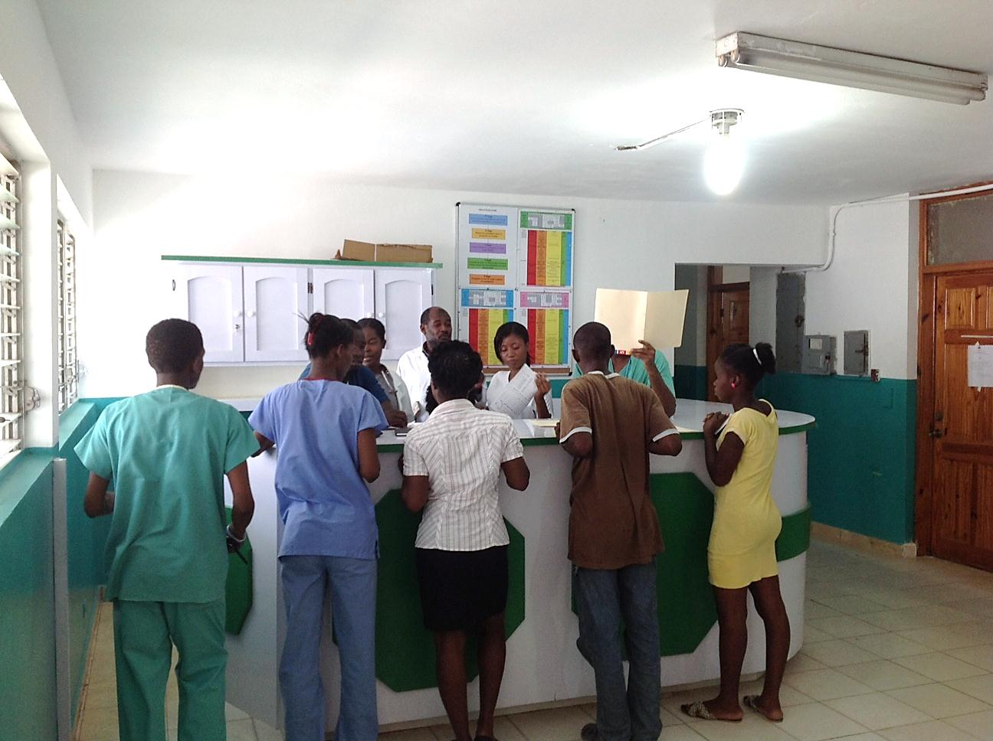
Photo: Improved hospital emergency services with space dedicated to triage of patients

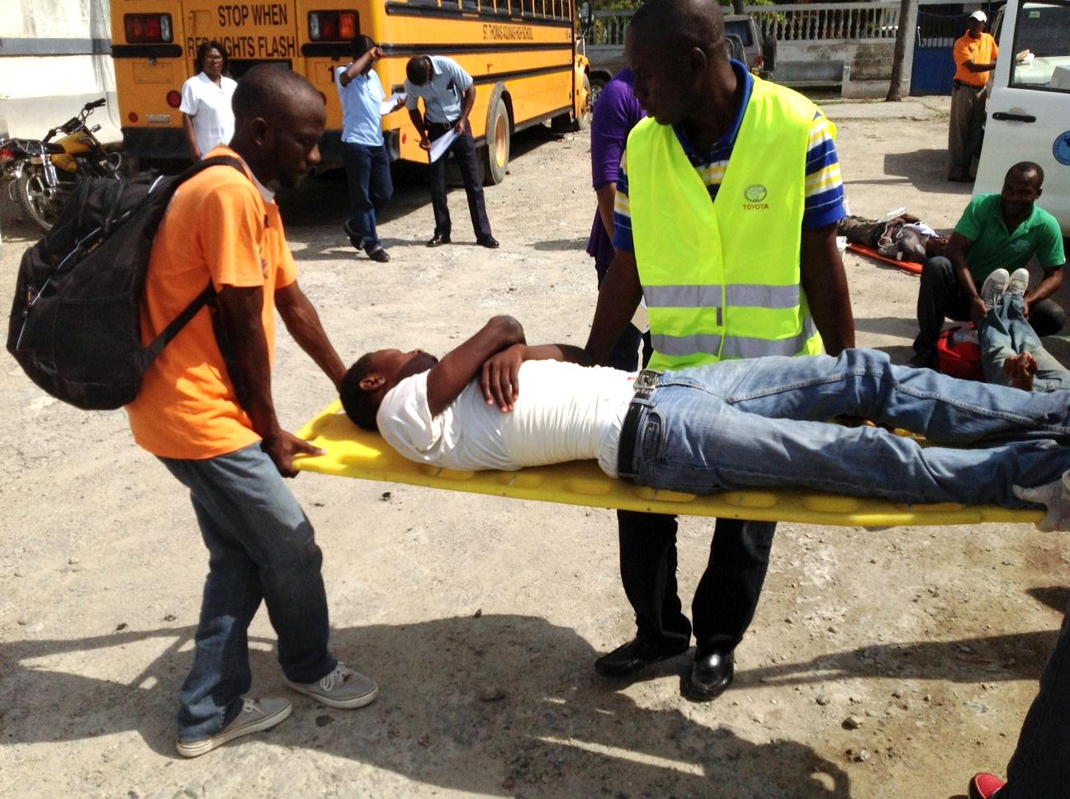
Photo: Simulation exercise for the management of emergencies (here simulation of road accident)

